**A PROJECT REPORT**

**ON**

**“Wine & DINE”**

***Submitted by***

Karan Deopura (130410107014)

Reecha Roy (130410107094)

***External Guide Internal Guide***

Mr. Nitin Deopura, Aecor Technology Prof. Keyur Upadhyay

***In partial fulfillment for the award for project***

***of***

**BACHELOR OF ENGINEERING**

***in***

**COMPUTER ENGINEERING DEPARTMENT**



**Gujarat Technological University, Ahmedabad**

**October, 2016**

**ACKNOWLEDGEMENT**

It relinquishes us with rapture and gratification in presenting this report of the Project undertaken during the Final Year of B.E. As it is the first step into our Professional Life, we would like to acknowledge the contribution and assistance of key individuals, without their help and encouragement, it wouldn’t have been possible for us to carry out the desired work.

We are thankful to **Aecor Technology Pvt. Ltd.** for allowing me to work at their office. I would like to take this opportunity to express my heartfelt gratitude to it.

We are thankful to **Mr. Keyur N. Upadhyay (Computer Department, SVIT, Vasad)** for guiding us in our project and sharing his valuable knowledge with us. By his uncompromising demand for quality and his insistence for meeting the deadlines, we were able to do such an excellent work. We are also very much thankful to all faculty members for their support and giving invaluable feedback to us.

Our special thanks to our parents, friends and well-wishers for providing the support without which this task would not be accomplished.

And finally, our sincere thanks to our class-mates, who have provided us many technical and friendly tips. Without their cordial and friendly support, this activity would have been much tougher.

**Karan Deopura (130410107014)**

**Reecha Roy (130410107094)**

**Abstract**

With the onslaught of 21st century, everything has become computerized. People are more familiar with digital devices. Nowadays paper works are replaced by computers and smartphones.

In this competitive world, reducing cost and increasing productivity become necessary. Particularly, manpower is more expensive for restaurants. In this situation, an automated system can help to increase productivity. It also helps in increasing the efficiency, decrease processing time and increases the experience quality for customers.

This project focuses on developing a food ordering management, order retrieval system, managing menu and evaluating its effects on efficiency of process and customer satisfaction. It has four core items: requirements analysis, implementation, testing and evaluation. As a starting point, a restaurant is identified based on selection criteria. The requirements are gathered from the partner restaurant and user survey. The evaluation of system shows the effects of introducing the system and customer satisfaction.

**Certificate of Plagarism**

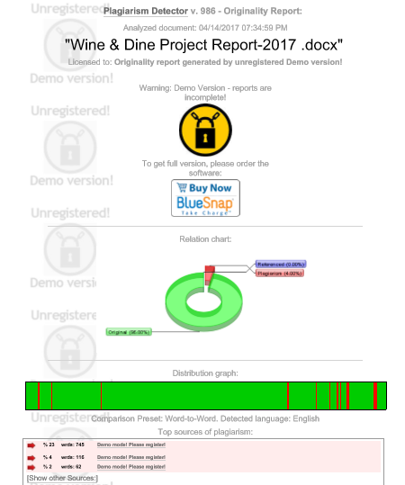

**UNDERTAKING ABOUT ORIGINALITY OF WORK**

We hereby certify that we are the sole authors of this IDP/UDP project report and that neither any part of this IDP/UDP project report nor the whole of the IDP/UDP Project report has been submitted for a degree by other student(s) to any other University or Institution.

We certify that, to the best of our knowledge, the current IDP/UDP Project report does not infringe upon anyone’s copyright nor violate any proprietary rights and that any ideas, techniques, quotations or any other material from the work of other people included in our IDP/UDP Project report, published or otherwise, are fully acknowledged in accordance with the standard referencing practices. Furthermore, to the extent that we have included copyrighted material that surpasses the boundary of fair dealing within the meaning of the Indian Copyright (Amendment) Act 2012, we certify that we have obtained a written permission from the copyright owner(s) to include such material(s) in the current IDP/UDP Project report and have included copies of such copyright clearances to our appendix.

We have checked the write up of the present IDP/UDP Project report using anti-plagiarism database and it is in the allowable limit. In case of any complaints pertaining to plagiarism, we certify that we shall be solely responsible for the same and we understand that as per norms, University can even revoke BE degree conferred upon the student(s) submitting this IDP/UDP Project report, in case if it is found to be plagiarized.

Karan Deopura (130410107014)

Reecha Roy (130410107094)

Place: Vasad

Internal Guide: Prof. Keyur.N.Upadhyay

**List of Figures**

**Figure No. Figure Description Page No.**

Fig. 2.3.1(a) Prototype Model 17

Fig. 2.3.2 Block diagram of system 18

Fig. 2.4.1.1 Admin Use case diagram 19

Fig. 2.4.1.2 Customer Use-case diagram 20

Fig. 2.4.1.3 Waiter Use-case diagram 20

Fig. 2.4.1.4 Kitchen Use-case diagram 21

Fig. 2.4.2.1 Entity-Relationship diagram 22

Fig. 2.4.3.1 Activity diagram for admin 23

Fig. 2.4.3.2 Activity diagram for customer 24

Fig. 2.4.3.3 Activity diagram for kitchen 25

Fig. 2.4.4.1 Sequence diagram for admin 26

Fig. 2.4.4.2 Sequence diagram for customer 27

Fig. 2.4.4.3 Sequence diagram for kitchen 27

Fig. 2.4.7 Snapshot of Firebase database 28

Fig. 2.5.1.1 AEIOU Summary 29

Fig. 2.5.2.1 Empathy Summary 31

Fig. 2.5.3.1 Ideation Summary 32

Fig. 2.5.4.1 Product Development 34

Fig. 2.5.5.1 Business Model Canvas 36

Fig. 3.1.1 Snapshot of Android Studio 37

Fig. 3.1.2 Snapshot of Firebase 38

Fig. 3.2.1 Snapshot of Login Screen 39

Fig. 3.2.2 Snapshot of Register Screen 40

Fig. 3.2.3 Snapshot of Home Screen 41

Fig. 3.2.4 Snapshot of Menu Page Screen 42

Fig. 3.2.5 Snapshot of Individual Menu screen 43

Fig. 3.2.6 Snapshot of Empty cart screen 44

Fig. 3.2.7 Snapshot of Cart screen 45

Fig. 3.2.8 Snapshot of Navigation drawer screen 46

Fig. 3.2.9 Snapshot of Order placing 47

Fig. 3.2.10 Snapshot of Order status screen 48

Fig. 3.2.11 Snapshot of Admin Login screen 49

Fig. 3.2.12 Snapshot of Admin Register Screen 50

Fig. 3.2.13 Snapshot of Forgot Password Screen 51

Fig. 3.2.14 Snapshot of Admin Home Screen 52

Fig. 3.2.15 Snapshot of Add menu screen 53

Fig. 3.2.16 Snapshot of Update Menu screen(1) 54

Fig. 3.2.17 Snapshot of Update Menu screen(2) 55

Fig. 3.2.18 Snapshot of Delete menu screen 56

Fig. 3.2.19 Snapshot of Individual Table Screen 57

Fig. 3.2.20 Snapshot of Waiter’s Call screen 58

Fig. 3.2.21 Snapshot of Kitchen home screen 59

Fig. 3.2.22 Snapshot of Individual Table Order screen 60

**Table of Content**

**Acknowledgement**

**Abstract**

**Industrial Completion certificate**

**Certificate of College**

**Certificate of Completion**

**Certificate of Plagiarism**

**Undertaking about Originality of Work**

**List of Figures**

**Chapter 1 Introduction**

* 1. Problem Summary………………………………………………....................................11
  2. Objective……………………………………………………………..............................11
  3. Solution………………………………………………………........................................12
  4. Literature Review……………………………………………………………………….12
  5. Plan of work…………………………………………………………………………….12

**Chapter 2 Design: Analysis, Design Methodology and Implementation Strategy**

2.1 Requirement Gathering

2.1.1 Functional Requirement…………………………….............................................13

2.1.2 Non-Functional Requirement……………………….............................................14

2.1.3 Software Requirement………………………………............................................14

2.1.4 Hardware Requirement………………………………….……..............................14

2.2 Study of Feasibility

2.2.1 Technical Feasibility…………………………………………..............................15

2.2.2 Economic Feasibility……………………………………………………………..15

2.2.3 Time Feasibility………………………………………………………………….16

2.2.4 Schedule Feasibility…………………………………...........................................16

2.3 System Design

2.3.1 Software Development Model…………………...……………………................16

2.3.2 Architecture Model.……………………………………………………………...17

2.4 System Diagrams

2.4.1 Use Case Diagram………………………………………………...……………..19

2.4.2 Entity-Relationship Diagram…………………………………………...………..22

2.4.3 Activity Diagram……………………………………...........................................23

2.4.4 Sequence Diagram……………………………………………………………….26

2.4.5 Data Dictionary……………………………………..............................................28

2.4.6 Firebase Database………………………………………………………………...28

2.5 Canvas

2.5.1 AEIOU Summary……………………………………….......................................29

2.5.2 Empathy Summary…………………………………….........................................31

2.5.3 Ideation Canvas ………………………………………………..............................32

2.5.4 Product Development………………………………….........................................34

2.5.5 Business Model Canvas………………………………………………………….36

**Chapter 3 Implementation**

3.1 Programming…………………………………………………………………………....37

3.2 Snapshots………………………………………………………………………………..39

**Chapter 4 Result Summary**…………………………………………………………………61

**References**…………………………………………………………….......................................62

**Appendix**……………………………………………………………………………………….64

**Chapter-1: INTRODUCTION**

* 1. **Problem Summary**

In general, people go to restaurants for relaxing, chatting and having food/drinks pleasantly. Usually on the weekends the restaurants are fully occupied. At this time, people have to wait for a waiter to order food/drinks. In addition to this, during rush hour waiters are very busy. Sometimes they might forget to take orders, serve wrong order and order processing also take long time. When the restaurant introduces a new menu or some recipes which are new for customers, they can’t get it easily by seeing the menu card.

So, we introduce the system, Wine & Dine is the system for managing the restaurant and online food ordering. The main point of developing this system is to help restaurant administrator to manage the restaurant and help customer for online food ordering and order retrieval and billing process.

Problems occur due to present system:

* Mainly restaurant manage their business by manual system and this may require more paper work.
* Sometimes restaurant administrator faces difficulty in managing the documents of waiter’s information, business reports, etc.
* Waiters take food order reaches to kitchen and after food being cooked waiter serve it to the customer – Consumes more time.
* Require more waiters/waitress to give more efficient service.
* Changes on an order can’t make in a blink of an eye time.

**1.2 Objectives**

This project has been designed keeping in mind some of the problems faced by the restaurants & its staff.

* Online ordering system
* User friendly graphical interface
* Provide online menu information
* Increase in sales and productivity
* Increase profitability by eliminating unnecessary and wasteful purchase
* Increase efficiency through detailed reporting

**1.3 Solutions**

Considering the existing problem, the following are the solution provided by our system are as follows.

* It eradicates the wastage of paper by computerized system.
* Software application will make changes in present menu displaying, food ordering, customer’s information management, waiter’s information management, report generation, etc.
* E-invoice will eradicate the billing problems.

**1.4 Literature Review**

|  |  |  |  |
| --- | --- | --- | --- |
| Title | Author | Publication | Year |
| Object Oriented Modeling & Design with UML | Michael.R.blaha, James.R.Rumbaugh | Pearson India | 2007 |
| Software engineering: A Practitioner’s Approach | Roger S Pressman | MCGRAW-HILL COLLEGE | 2014 |

***Table 1: Literature Review***

**1.5 Plan of Work**

* Search about the project topic (Shodh Yatra)
* Realization of the Abstract
* Briefing over the project with our project guides
* Analysis of the Requirement
* Discussion over which tools to be used over the duration
* Study of Feasibility
* System Design to used
* System Diagrams

**Chapter-2: DESIGN: ANALYSIS, DESIGN METHODOLOGY AND IMPLEMENTATION STRATEGY**

**2.1 Requirement Gathering**

For any project and managing of project, Requirement gathering is the important part of it. For the successful implementation of the project, understanding the system thoroughly is most important.

It includes three types of activities:

1. Eliciting Requirements
2. Analysis of Requirement
3. Recording Requirements

**2.1.1 Functional Requirement**

1. **Online food ordering system**

Customer must be provide the following functionality

* Scan QR code
* Enter the information
* Navigate the restaurant’s menu
* Select and add item from the menu to cart
* Place and cancel order
* Receive order status
* Receive invoice either through mail or through message on check out

1. **Menu management system**

The menu is managed by the admin/manager of restaurant. The functions offer is

* Add/update/delete food item or food menu from the menu
* Update the price for a food item
* Add/delete the special offers
* Validate the payment after completion of order

1. **Order Retrieval System**

This is designed to use only by the restaurant employee and provide the following functions:

* Retrieve the order from the ordered queue
* Notify the customer with the order status.
* Remove the order from the list of active orders if the ordered is being processed

**2.1.2 Non-Functional Requirement**

1. **System will have consistent and friendly user interface**

We will try to design the user-interface in such a way that it will be easy for any users to interact with system. Suppose user makes mistake, the system will provide an appropriate error message that will guide the user for the further interaction.

1. **Each module will be integrated with each other**

Data control and information flow between each and every modules of the system and they communicate with each other and tightly integrated.

1. **Availability**

The system will be available during the restaurant hours.

1. **Security**

The QR-code technique used to identify the table as well as to provide the security to the system that it will not used outside the restaurant.

**2.1.3 Software Requirement**

**Developing side**

* Android studio
* Web browser
* PhpMyAdmin and Firebase
* Windows 7 or above devices
* Internet connection

**Client side**

* Android supported smartphones/tablets with Jellybean or above version
* Internet connection

**2.1.4 Hardware Requirement**

* Windows OS running device
* Processor – Pentium, core i3 and above
* RAM – minimum 2GB, recommended 4GB
* Hard disk – minimum 256GB

**2.2 Study of Feasibility**

**2.2.1 Technical Feasibility**

Technical Feasibility refers to the ability of process to take benefits of current state of technology by plying further improvement. Technical feasibility will be addressed by subsequent explanation. The suggested technology is practically quite feasible. It is mature enough to tackle the problems and provide necessary services. This system will comprise of a larger database and technology needs to be very sharp practically. The suggested technology is currently available and has proven to be worth the effort. Availability of the suggested technology is not a laborious task. To achieve these goals and to design this application we require following hardware and software:

**System Platform**

* Microsoft Windows 7 and upwards.
* Pentium Core i3 and above or any other compatible processor.
* RAM – 2 GB
* 256 GB HDD

**Development Tools:**

* Android Studio

**Software Platform:**

* Technologies – Android, PHP
* Database Server- PhpMyAdmin, Firebase

**2.2.2 Economical Feasibility**

Economic feasibility monitors the financial aspects of the project. Economic feasibility has been done in advance for recognising the cost of the system. Cost-efficient analysis of the system is done. Here all the costs are scheduled to the system i.e. direct and indirect costs are calculated to see whether it is affordable or not. A software product needs to be a good investment for the organization. Financial benefits must equal or exceed the costs. Our system need one-time investment for a restaurant. The system would require tools like Android Studio, Firebase and PhpMyAdmin. This softwares are easily available and would be affordable to use for developing the system. So, the system will be feasible economically given the constraints and functionalities to be completed in given amount of time.

**2.2.3 Time Feasibility**

Projects are initiated with specific deadline. We need to evaluate whether the deadlines are mandatory or desirable. In the development of any system, time management is a crucial factor. But we can manage it with the proper guidance and knowledge.

We have been asked to complete the project within the working days of the organization having period of 7-8 months approximately. So, we have managed to complete the project before given deadline. As per our application, we have already divided our time for different task for analysis, designing and coding. We are giving appropriate time for all tasks. Currently we are focusing on analysis phase and designing phase as they are the most important aspect for project. After completing this phase, we will start coding for project.

**2.2.4 Schedule Feasibility**

**Table 1: Timeline chart**

|  |  |  |  |  |  |  |  |  |  |
| --- | --- | --- | --- | --- | --- | --- | --- | --- | --- |
| Months  Tasks | August 2016 | September 2016 | October 2016 | November 2016 | December 2016 | January 2016 | February 2016 | March 2016 | April 2016 |
| Planning | *Planning Phase* | |  |  |  |  |  |  |  |
| Design |  | *Design phase* | | |  |  |  |  |  |
| Coding |  |  |  | *Coding phase* | | |  |  |  |
| Testing |  |  |  |  |  |  | *Testing phase* | |  |
| Delivery |  |  |  |  |  |  |  |  | *Delivery* |

**2.3 System Design**

**2.3.1 Software Development Model**

The software development model which is used is “**Prototyping Model**”. The Prototyping Model is a type of evolutionary process model in which the prototype is built, tested and feedback is obtained and again the prototype is built. This process works till the customer is satisfied. So the prototype model is iterative model. In this model, initially requirement gathering is done. After that a quick design is prepared. From this quick design, prototype is prepared. Customer evaluates the prototype in order to refine the requirements. Iteratively prototype is tuned for satisfying customer requirements. Thus, prototype is important to identify software requirement.

By using this prototype, the client can get an “actual feel” of the system, since the interactions with prototype can enable the client to better understand the requirements of the desired system. Prototype model should be used when the desired system needs to have a lot of interaction with the end users. Typically, online systems, web interfaces have a very high amount of interaction with end users, are best suited for Prototype model.

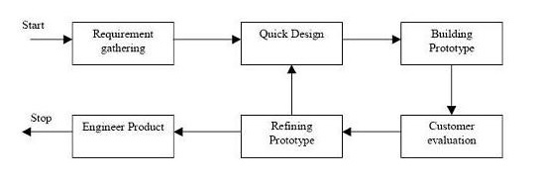

**Fig. 2.3.1(a) Prototype Model**

**Advantages:**

* Users are actively involved in the development
* Since in this methodology a working model of the system is provided, the users get a better understanding of the system being developed.
* Errors can be detected much earlier.
* Quicker user feedback is available leading to better solutions.
* Missing functionality can be identified easily
* Confusing or difficult functions can be identified by Requirements validation, Quick implementation of incomplete but functional application.

**Disadvantages:**

* Leads to implementing and then repairing way of building systems.
* Practically, this methodology may increase the complexity of the system as scope of the system may expand beyond original plans.
* Incomplete application may cause application not to be used as the full system was designed incomplete or inadequate problem analysis.

**2.3.2 Architecture Model**

The architecture model exhibits the communication between the various components of the system. It depicts the flow of information in a user-friendly manner and gives the overall picture of how the system functions.

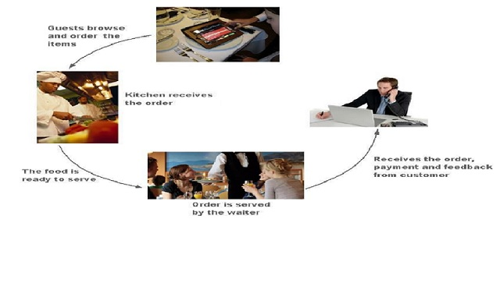

**Figure 2.3.2 Block Diagram of System**

**2.4 System Design**

**2.4.1 Use-case diagrams**

Use case are fundamental units of modelling language in which functionalities ae distinctly represented. Use-case depicts the software or system from end-user’s point of view. The basic use-case represents the high level scenario that describes the interaction between the actor and the system. 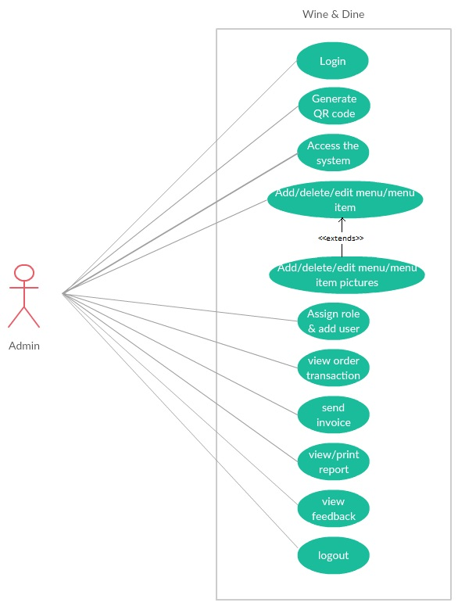

**Fig. 2.4.1.1 Admin Use-case diagram**

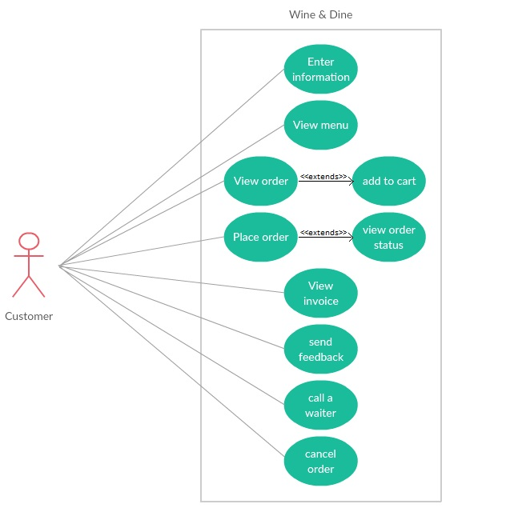

**Fig. 2.4.1.2 Customer Use-case diagram**

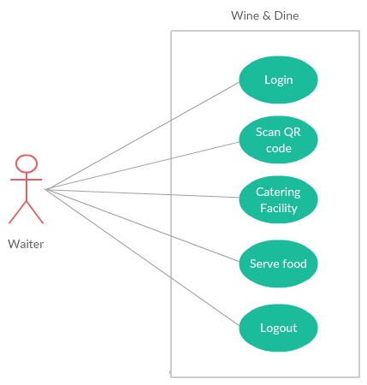

**Fig. 2.4.1.3 Waiter Use-case diagram**

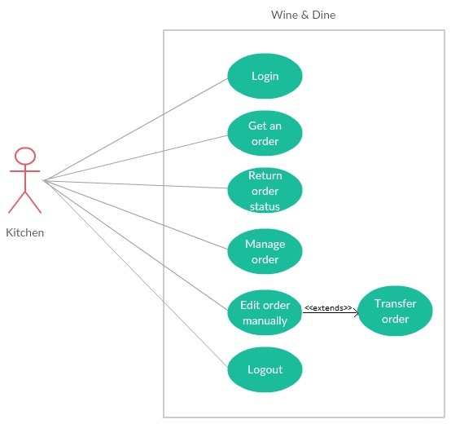

**Fig. 2.4.1.4 Kitchen Use-case diagram**

**2.4.2 Entity-Relationship diagram**

The object relationship pair can be graphically represented by a diagram called Entity Relationship Diagram(ERD). The ERD is mainly used in database applications but now it is more commonly used inn data design. The primary purpose of ERD is to represent the relationship between data objects. Various components are entity, relationship, attribute, etc.

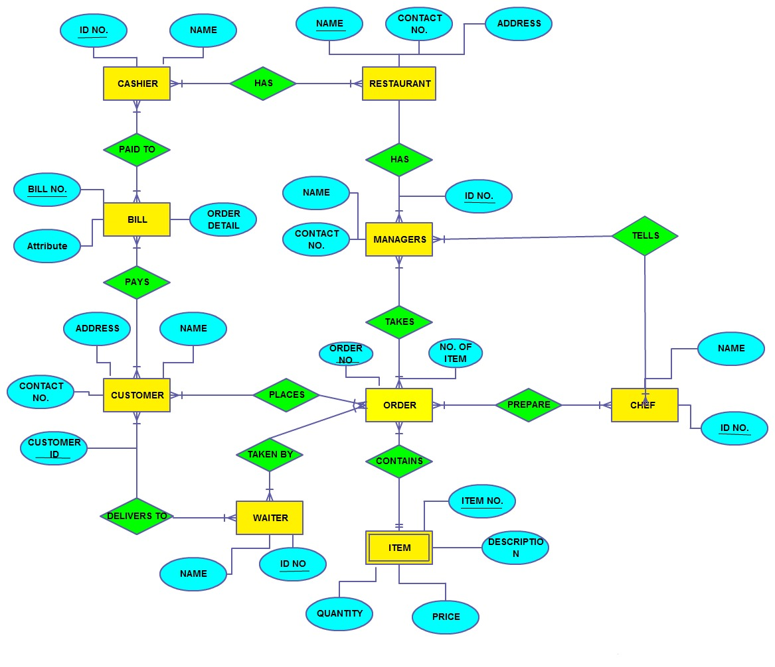

**Fig. 2.4.2.1 Entity-Relationship diagram**

**2.4.3 Activity diagram**

Activity diagram is graphical representation for representing the flow of interaction within specific scenarios. It is similar to flowchart. This diagram must read from top to bottom. It consists of forks and branches.

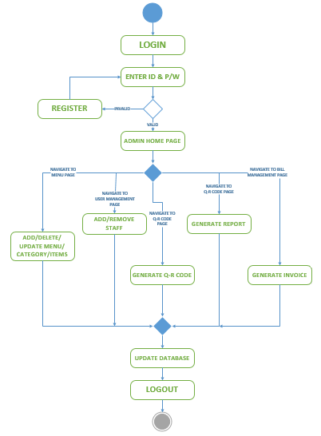

**Fig. 2.4.3.1 Activity diagram for admin**

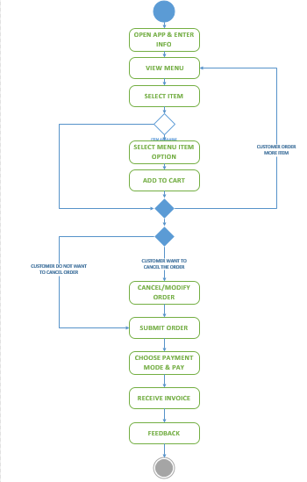

**Fig. 2.4.3.2 Activity diagram for customer**

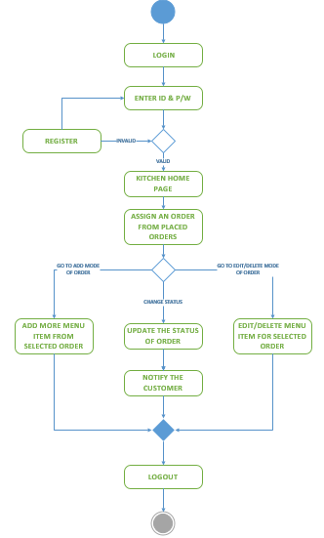

**Fig. 2.4.3.3 Activity diagram for kitchen**

**2.4.4 Sequence Diagram**

In the sequence diagram how the object interacts with the other object is shown. There are sequences of events that are represented by a sequence diagram. It is a time-oriented view of the interaction between objects to accomplish a behavioural goal of the system.

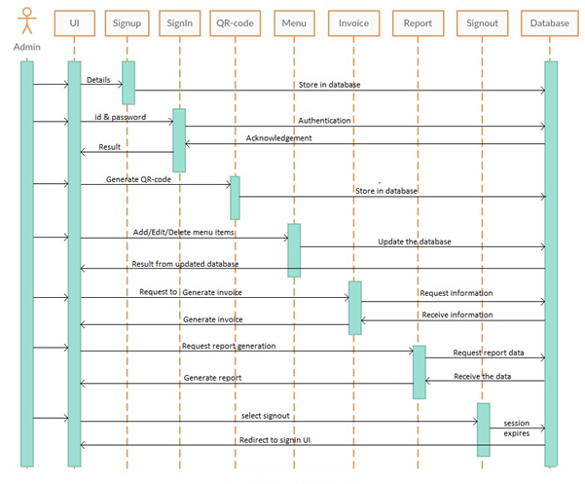

**Fig. 2.4.4.1 Sequence diagram for admin**

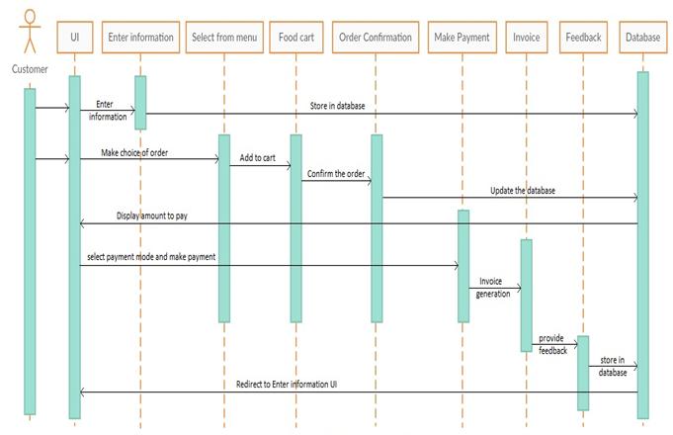

**Fig. 2.4.4.2 Sequence diagram for customer**

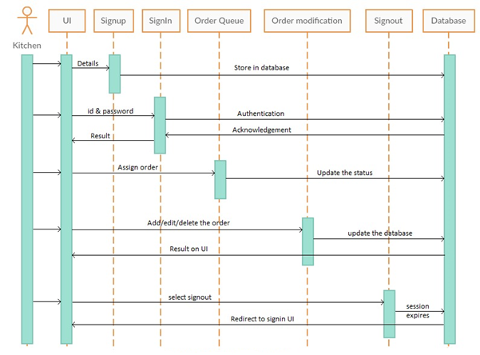

**Fig. 2.4.4.2 Sequence diagram for kitchen**

**2.4.5 Data Dictionary**

**Table 1: USER_MASTER**

|  |  |  |  |
| --- | --- | --- | --- |
| **Field_name** | **Field_type** | **Nullable** | **Description** |
| user_id | int | primary key | Id of user |
| user_name | varchar(30) | not null | Name of user |
| user_email | varchar(50) | null | Email of user |
| user_phone | bigint | not null | Phone number of user |

**Table 2: STAFF_MASTER**

|  |  |  |  |
| --- | --- | --- | --- |
| **Field_name** | **Field_type** | **Nullable** | **Description** |
| staff_id | int | primary key | Id of staff |
| staff_name | varchar(30) | not null | Name of staff |
| staff_password | varchar(20) | not null | Password for staff |
| staff_email | varchar(50) | not null | Email of staff |
| staff_phone | bigint | not null | Phone number of staff |
| staff_address | text | not null | Address of staff |
| staff_salary | decimal | not null | Salary of staff |
| staff_role | varchar(10) | not null | Role of staff |

**2.4.6 Firebase Database**

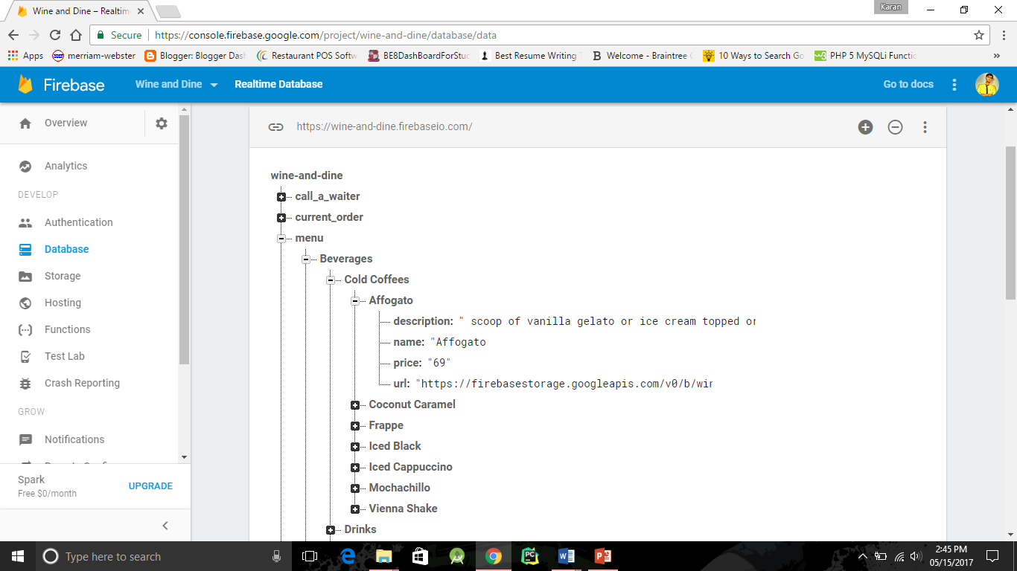

**Fig. 2.4.7 Snapshot of Firebase database**

**2.5 Canvas**

The commencement of our work on this project began with the observation of the current system being employed at the company and pinpointing the loopholes and drawbacks of the same. This study has been enlisted in the Empathy Summary and AEIOU Summary.

On acquiring a clear understanding about the present scenario the next phase was to ideate a solution to overcome the existing problem keeping in mind the company’s benefits. This study has been enlisted in the Ideation Canvas.

The next step was to work out a plan about how we are going to develop the product and what features it is going to have. The details of this study have been enlisted in Product Development Canvas.

* + 1. **AEIOU Summary**

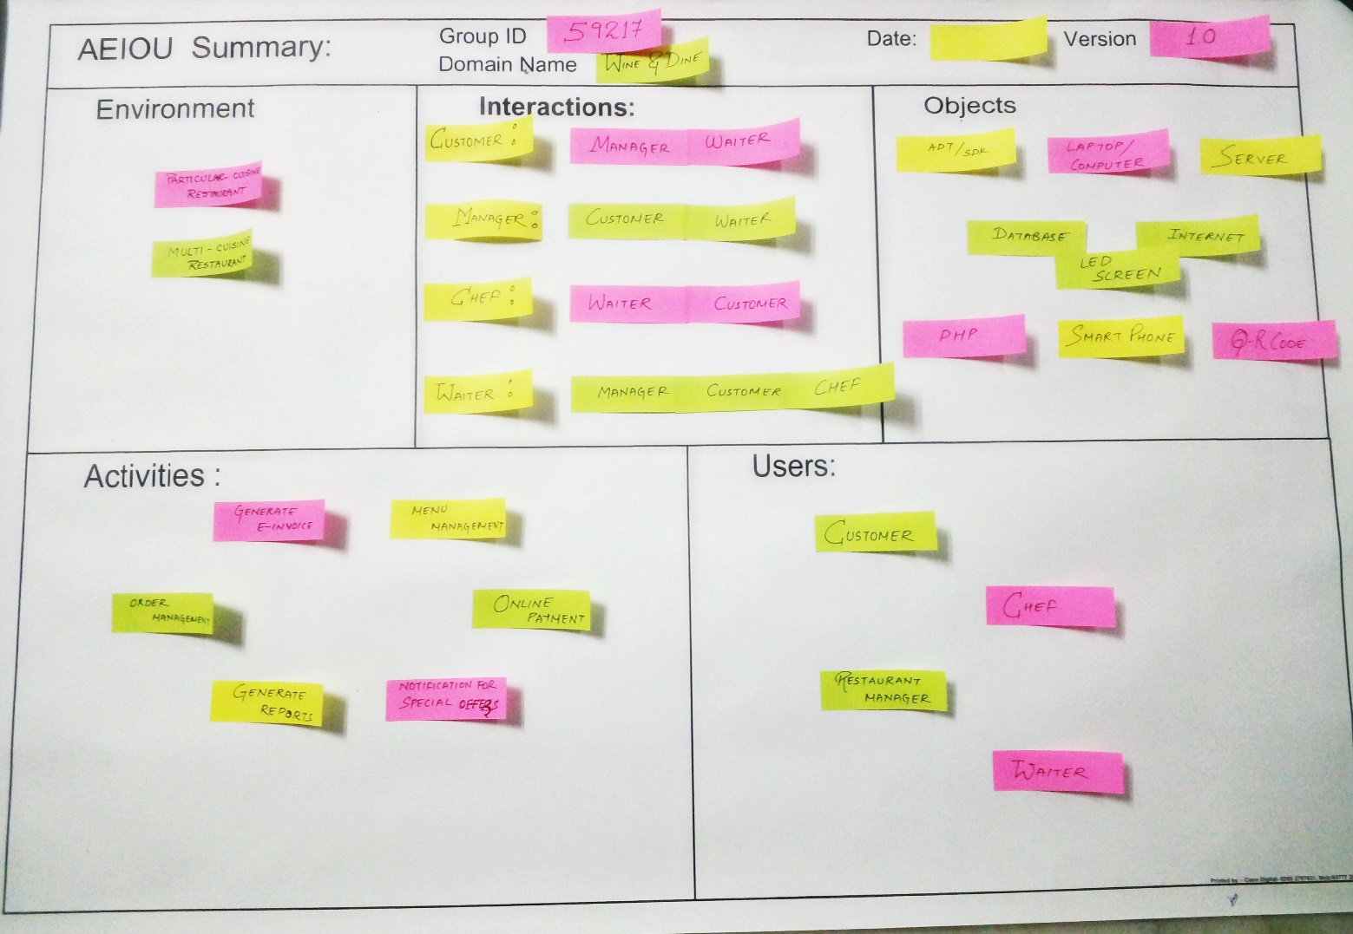

**Fig. 2.5.1.1 AEIOU Summary**

1. **Environment:**

It describes in which environment our system will work:

* Particular-cuisine restaurant
* Multi-cuisine restaurant

1. **Interactions:**

It describes the communication between devices and people respectively and who interact with whom:

* Customer communicates with manager and waiter
* Manager communicates with customer and waiter
* Chef communicates with waiter and customer
* Waiter communicates with customer, waiter and chef

1. **Objects:**

It describes which object is used and for what purpose:

* Android Development Tool
* LED screen
* Internet Connection
* Personal Computer/Laptop
* Server
* QR code
* Smart phones

1. **Activities:**

It describes the activities that are generally done by all:

* Generate report
* Menu management
* Online payment
* Order management
* Generate e-invoice
* Notification of special offers

1. **Users:**

It describes who are the users of the system:

* Customer
* Restaurant Manager
* Waiter
* Chef

**2.5.2 Empathy Mapping Canvas**

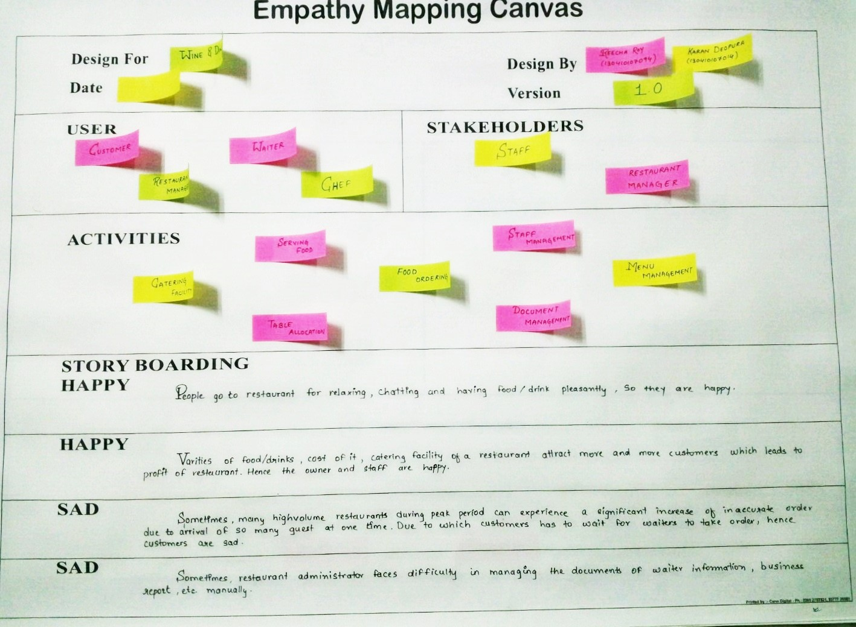

**Fig. 2.5.2.1 Empathy Mapping canvas**

It describes the Users, Stakeholders and Story Boarding while using the current system and activities carried out by the current system.

1. **Users**

It describes the user of the current system

* Customer
* Waiter
* Chef
* Restaurant manager

1. **Stakeholders**

It refers who may affect, be affected by a decision, activity, or outcome of a project.

* Restaurant Staff
* Restaurant Manager

1. **Activities**

* Food ordering
* Table allocation
* Staff management
* Document management
* Menu management
* Catering facilities
* Serving food

**2.5.3 Ideation canvas(Ideanaut)**

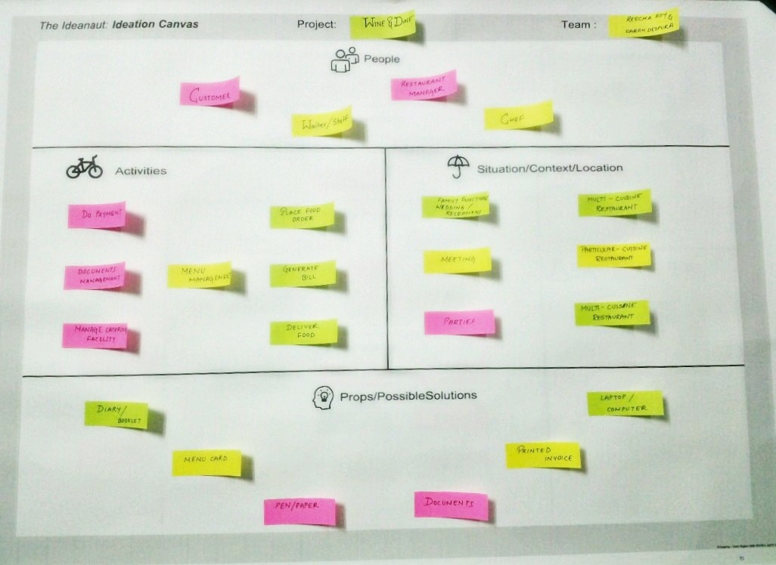

**Fig. 2.5.3.1 Ideanaut: Ideation canvas**

1. **People**

It describes people who are going to use the system:

* Customer
* Restaurant manager
* Chef
* Waiter

1. **Activities**

It describes the activities that are carried out by the people as mentioned above:

* Menu management
* Document management
* Make payment
* Place food order
* Generate invoice
* Manage catering facilities
* Deliver food and invoice

1. **Situation/Context/Location**

It describes the situation where system will be in use and location regarding that situation:

* For any parties or wedding reception, multi-cuisine restaurants are used
* For any meeting, either particular-cuisine or multi-cuisine restaurant is used

1. **Props/Possible solutions:**

It describes the various props and solutions available in order to enhance the functionality of the system:

* Diary/booklet
* Menu card
* Pen-paper
* Documents
* Printed invoice
* Laptop/Computer

**2.5.4 Product Development Canvas**

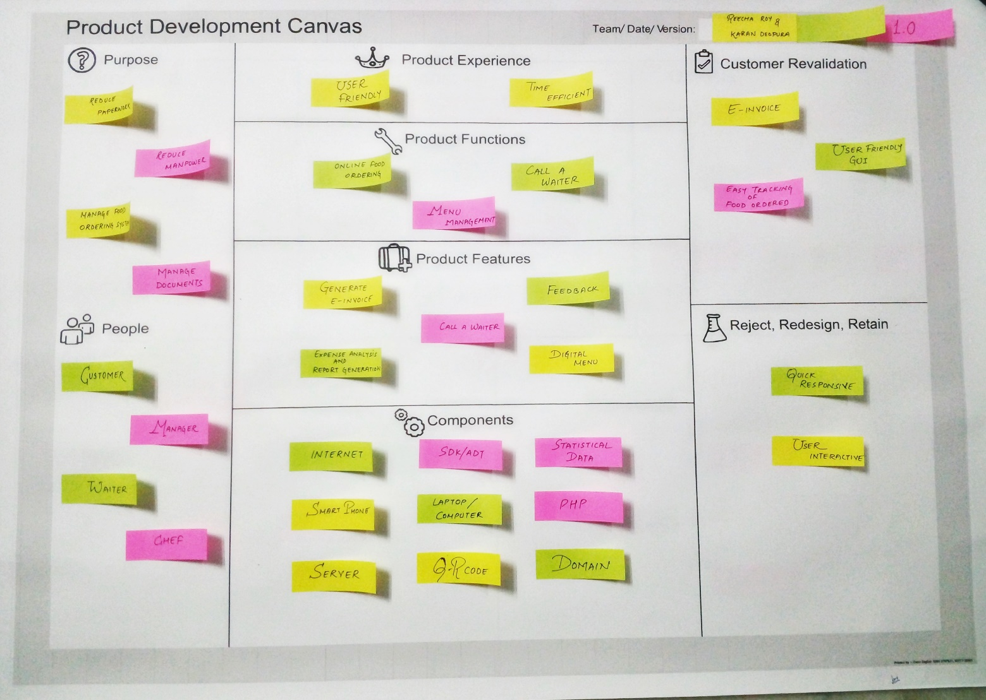

**Fig. 2.5.4.1 Product development canvas**

1. **Purpose**

It describes the reason for building the system:

* Reduce paperwork
* Reduce manpower
* Manage food ordering system
* Manage documents

1. **People**

It describes people involve in the system:

* Customer
* Restaurant manager
* Chef
* Waiter

1. **Product Experience:**

It describes the experiences of people after using the system:

* User friendly
* Time efficient

1. **Product functions:**

* Online food ordering
* Menu management
* Call a waiter

1. **Product features:**

* Generate e-invoice
* Feedback
* Call a waiter
* Expense analysis and report generation
* Digital menu

1. **Components:**

* Internet connection
* SDK/ADT tool
* PHP
* Statistical data
* Smart phones and Computer/Laptop
* Server
* QR-code
* LED screen

1. **Customer Revalidation:**

* E-invoice
* User friendly GUI
* Easy tracking of food ordered

1. **Reject, Redesign, Retain**

* Quick response
* User interactive

**2.5.5 Business Model Canvas**

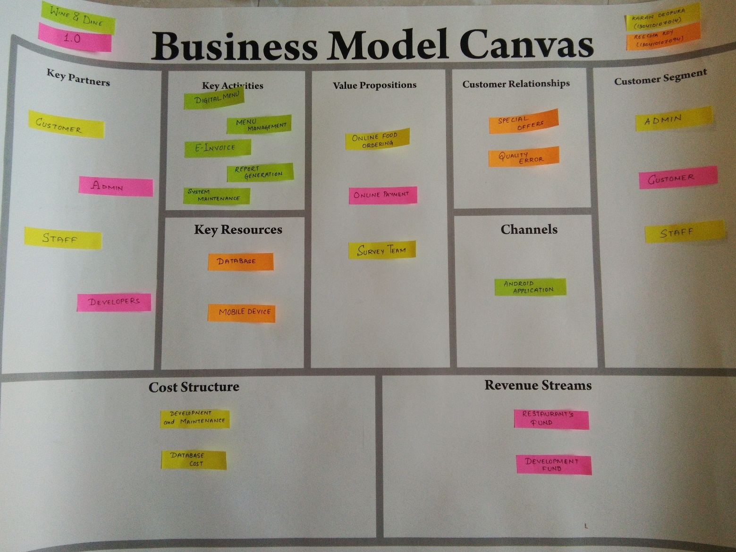

**Fig. 2.5.5.1 Business Model canvas**

After the completion of design of the product, it is important to arrange a business plan. The Business Model Canvas is a strategic management and lean start-up template for developing new or documenting existing business models. This canvas shows our product’s value, infrastructure, customers, and finances. This canvas helped us in identifying the business aspects of our product and the essentials for developing a product for mass production.

**Chapter-3: IMPLEMENTATION**

**3.1 Programming**

**1) Android Studio**

Android Studio is the official[integrated development environment](https://en.wikipedia.org/wiki/Integrated_development_environment) (IDE) for the [Android](https://en.wikipedia.org/wiki/Android_(operating_system)) platform. It was announced on May 16, 2013 at the [Google I/O](https://en.wikipedia.org/wiki/Google_I/O) conference. Android Studio is freely available under the [Apache License 2.0](https://en.wikipedia.org/wiki/Apache_License_2.0). Based on [JetBrains](https://en.wikipedia.org/wiki/JetBrains" \o "JetBrains)' [IntelliJ IDEA](https://en.wikipedia.org/wiki/IntelliJ_IDEA) software, Android Studio is designed specifically for Android development. It is available for download on [Windows](https://en.wikipedia.org/wiki/Windows), [macOS](https://en.wikipedia.org/wiki/MacOS) and [Linux](https://en.wikipedia.org/wiki/Linux), and replaced [Eclipse Android Development Tools](https://en.wikipedia.org/wiki/Eclipse_(software)#Eclipse_ADT_.28Android_Development_Tools.29) (ADT) as Google's primary IDE for native Android application development.

**Feature of Android studio: -**

* [Gradle](https://en.wikipedia.org/wiki/Gradle)-based build support.
* Android-specific [refactoring](https://en.wikipedia.org/wiki/Code_refactoring) and quick fixes.
* [Lint](https://en.wikipedia.org/wiki/Lint_(software)) tools to catch performance, usability, version compatibility and other problems.
* [ProGuard](https://en.wikipedia.org/wiki/ProGuard_(software)) integration and app-signing capabilities.
* Template-based wizards to create common Android designs and components.
* A rich [layout editor](https://en.wikipedia.org/wiki/Graphical_user_interface_builder) that allows users to drag-and-drop UI components, option to [preview layouts](https://en.wikipedia.org/wiki/WYSIWYG) on multiple screen configurations.
* Support for building [Android Wear](https://en.wikipedia.org/wiki/Android_Wear) apps.
* 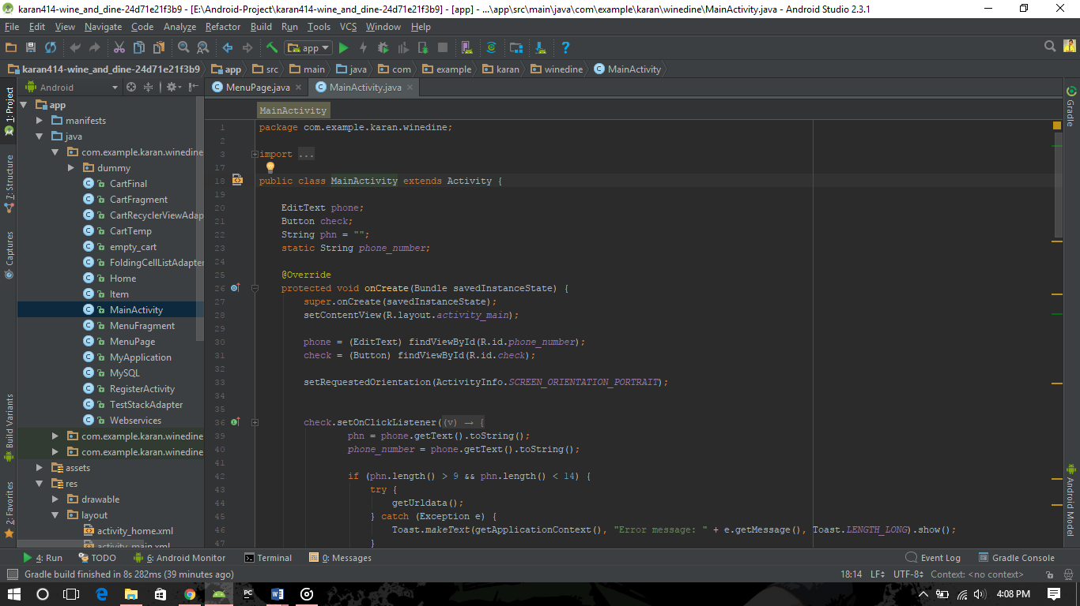Built-in support for Google Cloud Platform, enabling integration with Google Cloud Messaging and App Engine.

**Fig. 3.1.1 Snapshot of Android Studio**

**2) Firebase**

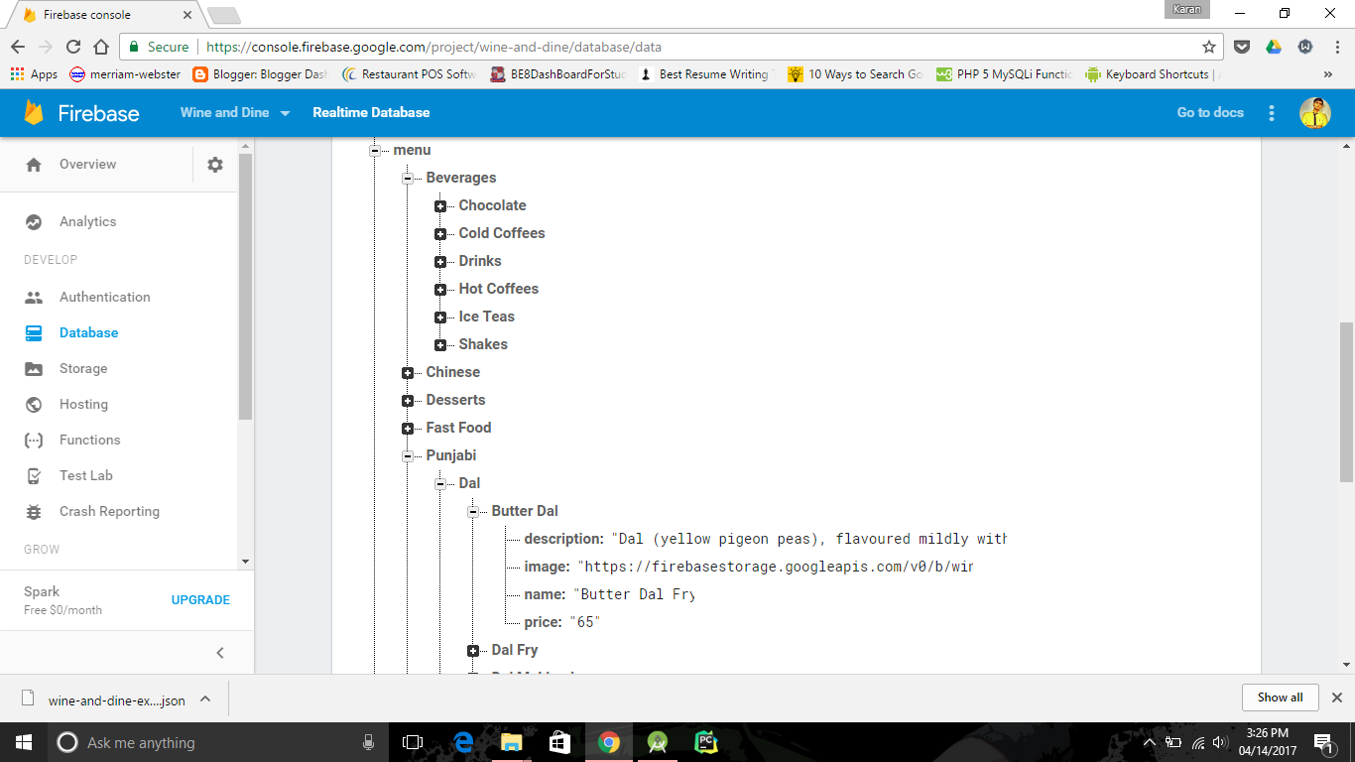Firebase is a [mobile](https://en.wikipedia.org/wiki/Mobile_application) and [web application](https://en.wikipedia.org/wiki/Web_application) platform with tools and infrastructure designed to help developers build high-quality apps. Firebase is made up of complementary features that developers can mix-and-match to fit their needs. The team is based in [San Francisco](https://en.wikipedia.org/wiki/San_Francisco) and [Mountain View, California](https://en.wikipedia.org/wiki/Mountain_View,_California). Firebase's initial product was a [real-time database](https://en.wikipedia.org/wiki/Realtime_database), which provides an [API](https://en.wikipedia.org/wiki/API) that allows developers to store and sync data across multiple clients. Over time, it has expanded its product line to become a full suite for app development.

**Fig. 3.1.2 Snapshot of Firebase**

**3.2 Snapshots**

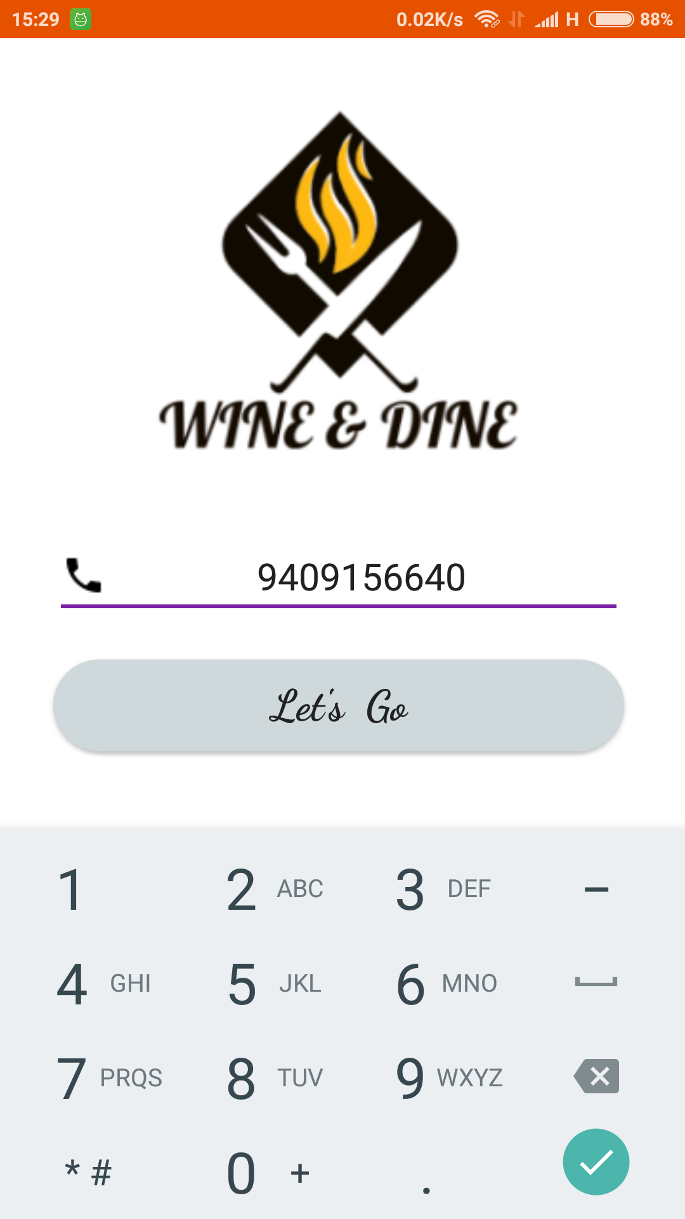

**Fig. 3.2.1 Snapshot of Login Screen**

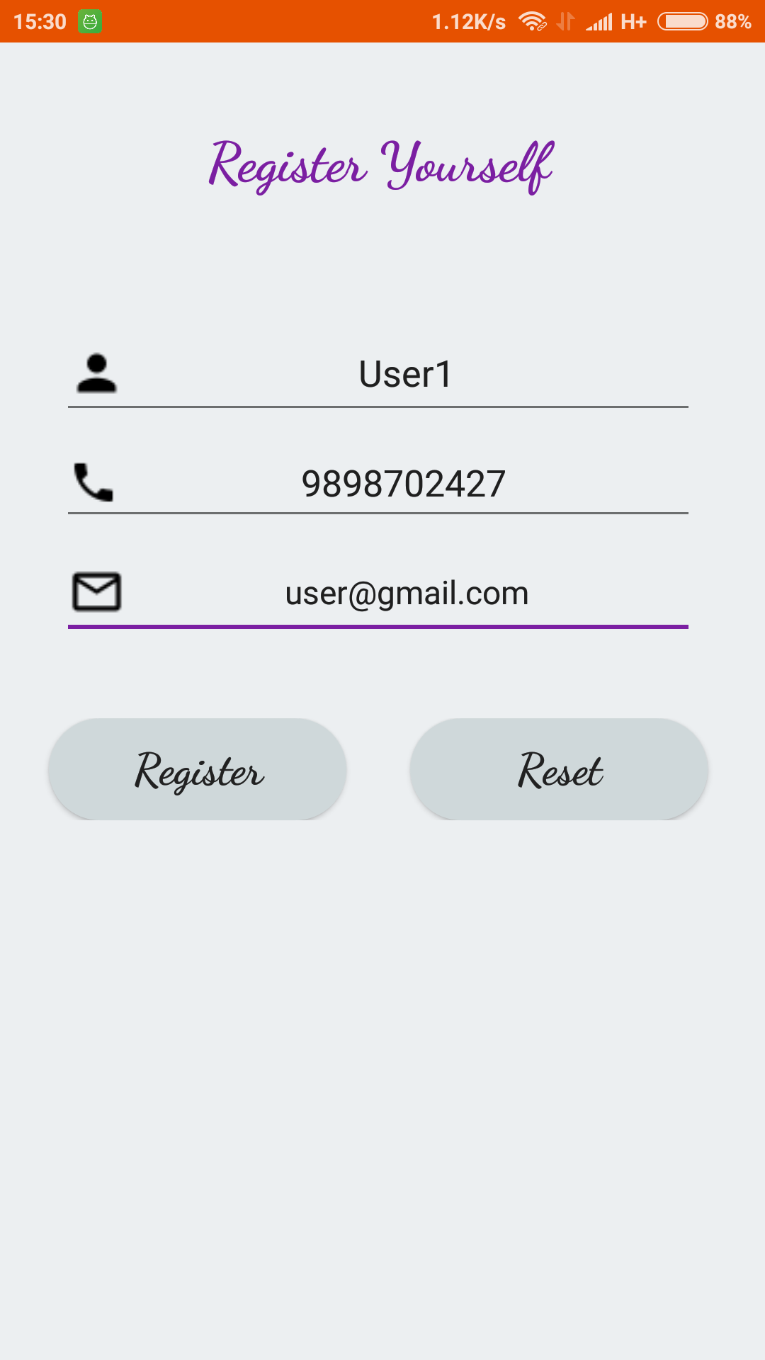

**Fig. 3.2.2 Snapshot of Register Screen**

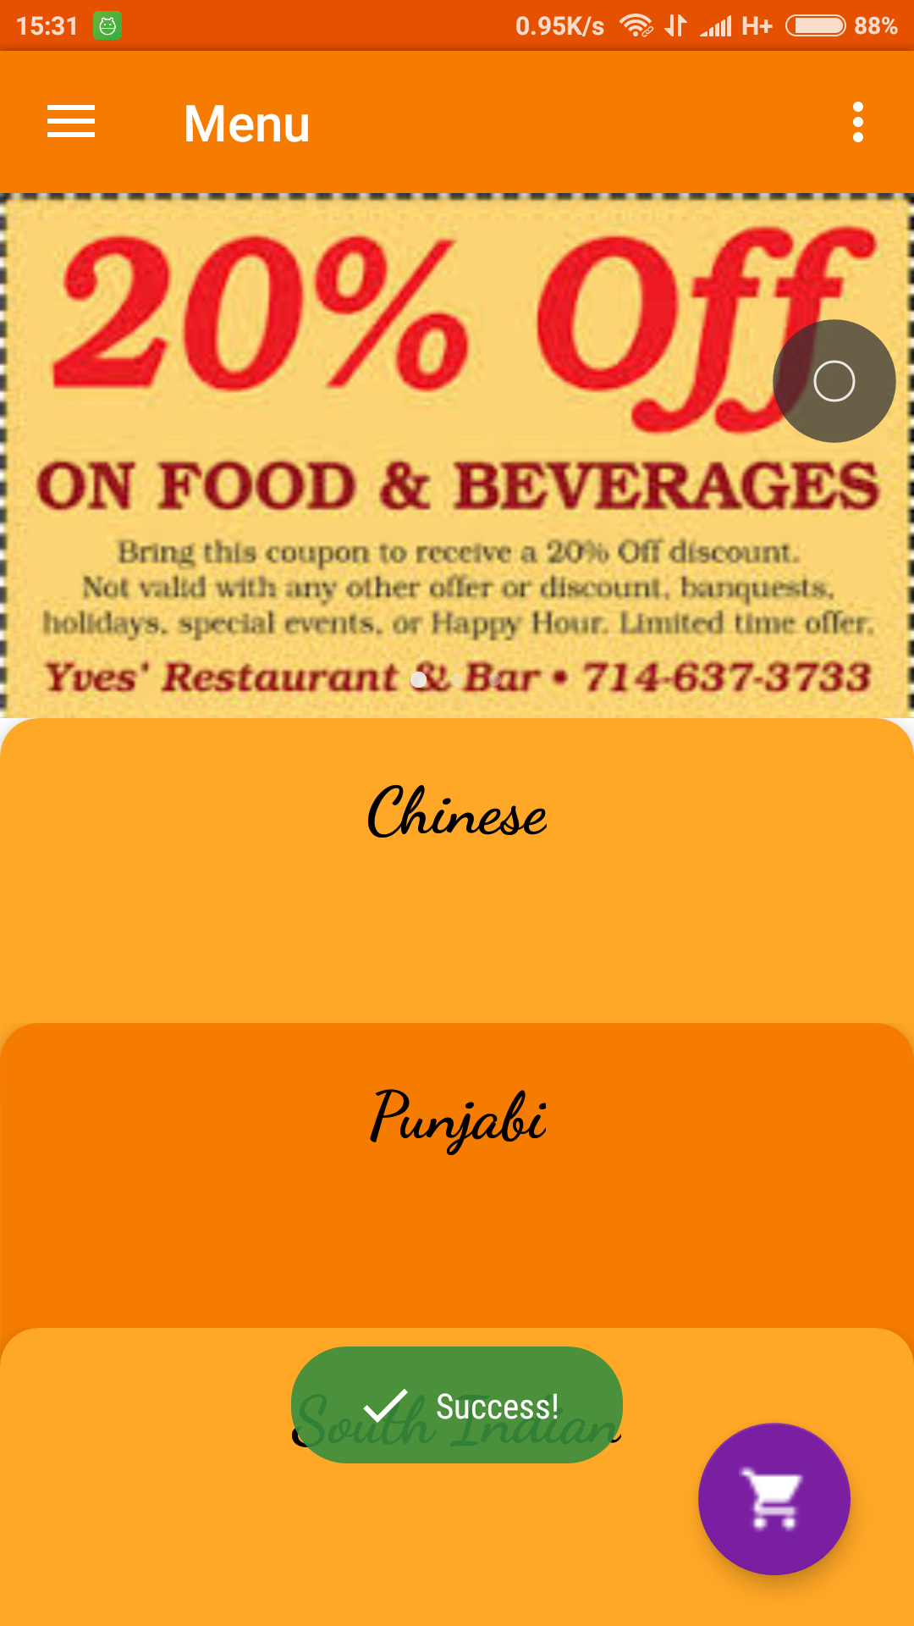

**Fig. 3.2.3 Snapshot of Home Screen**

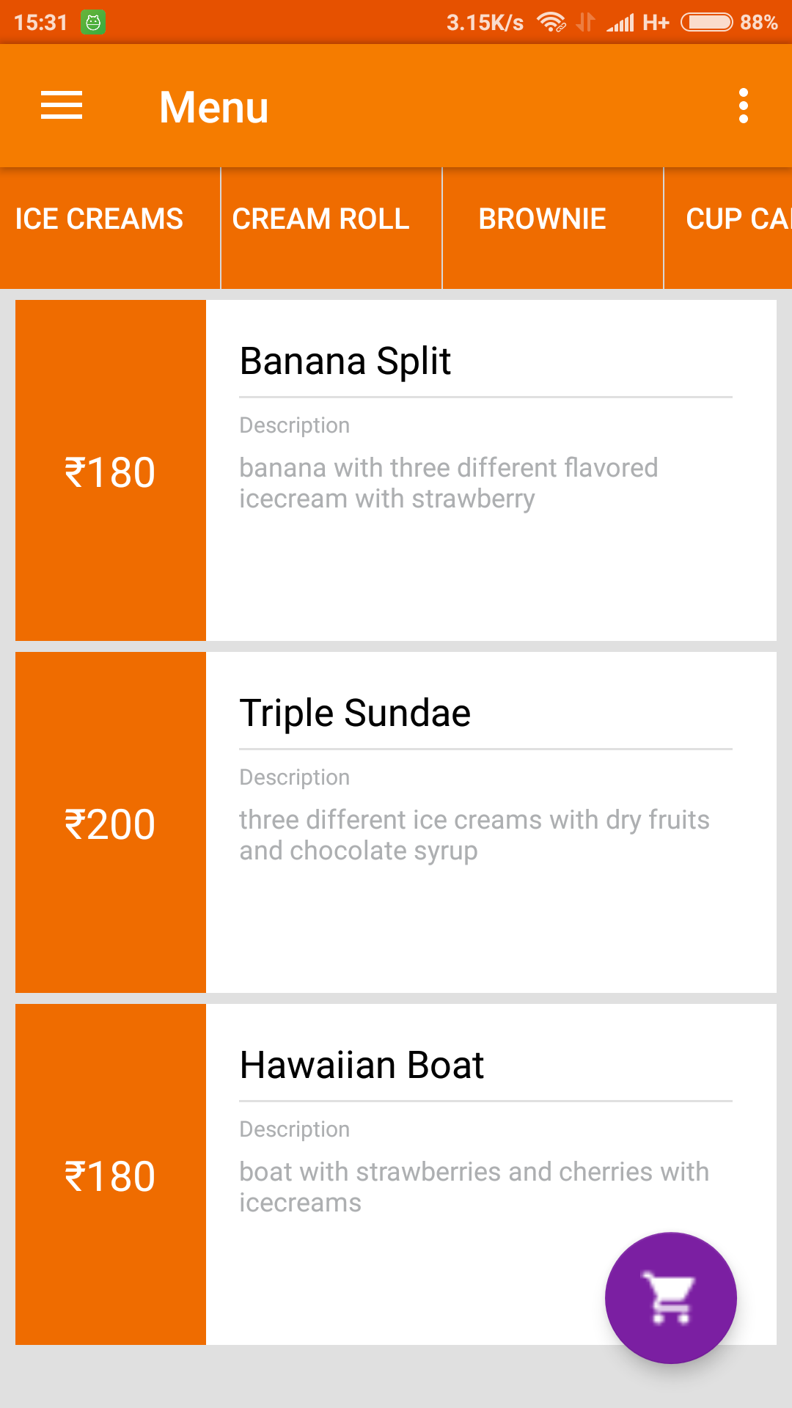

**Fig. 3.2.4 Snapshot of Menu page Screen**

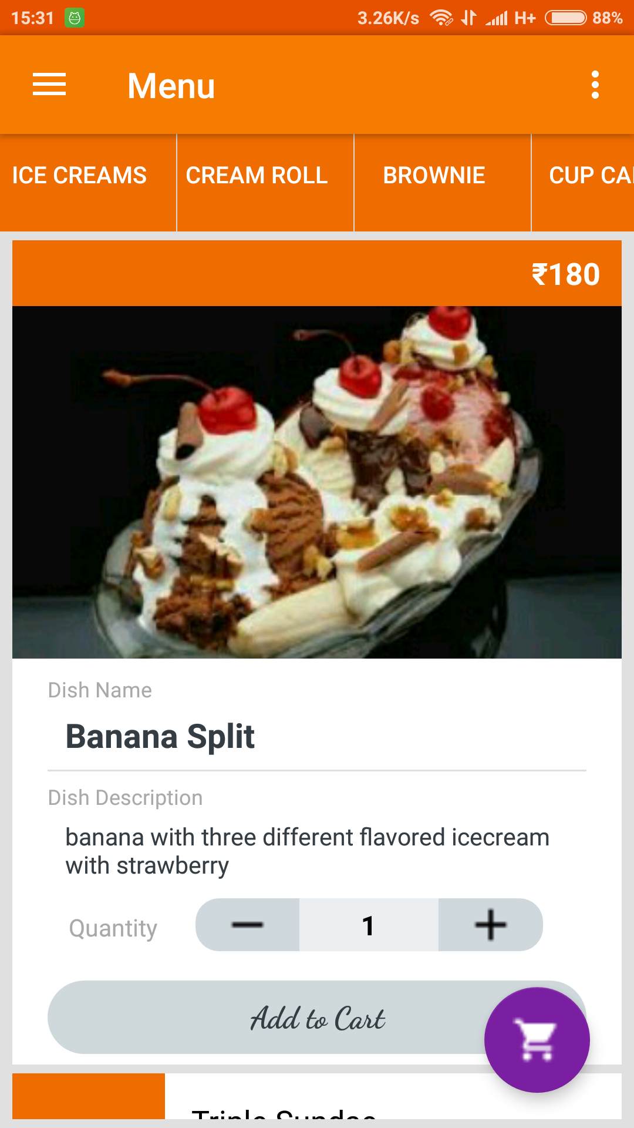

**Fig. 3.2.5 Snapshot of Individual Menu Screen**

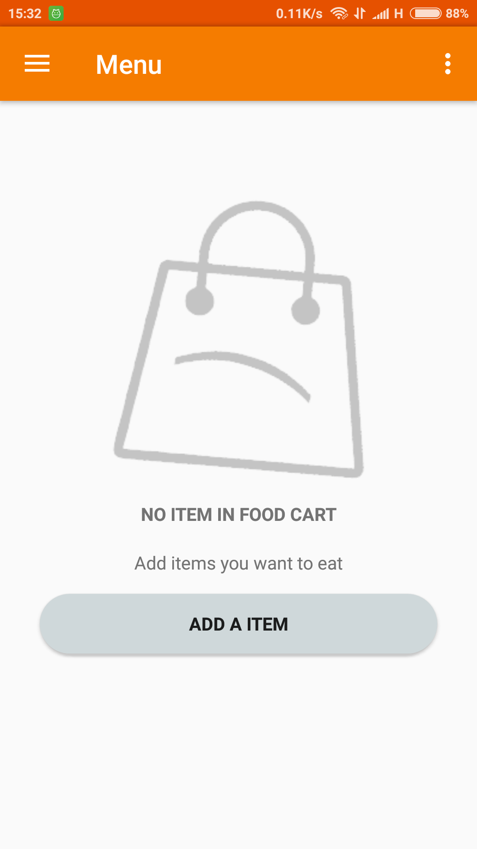

**Fig. 3.2.6 Snapshot of Empty cart Screen**

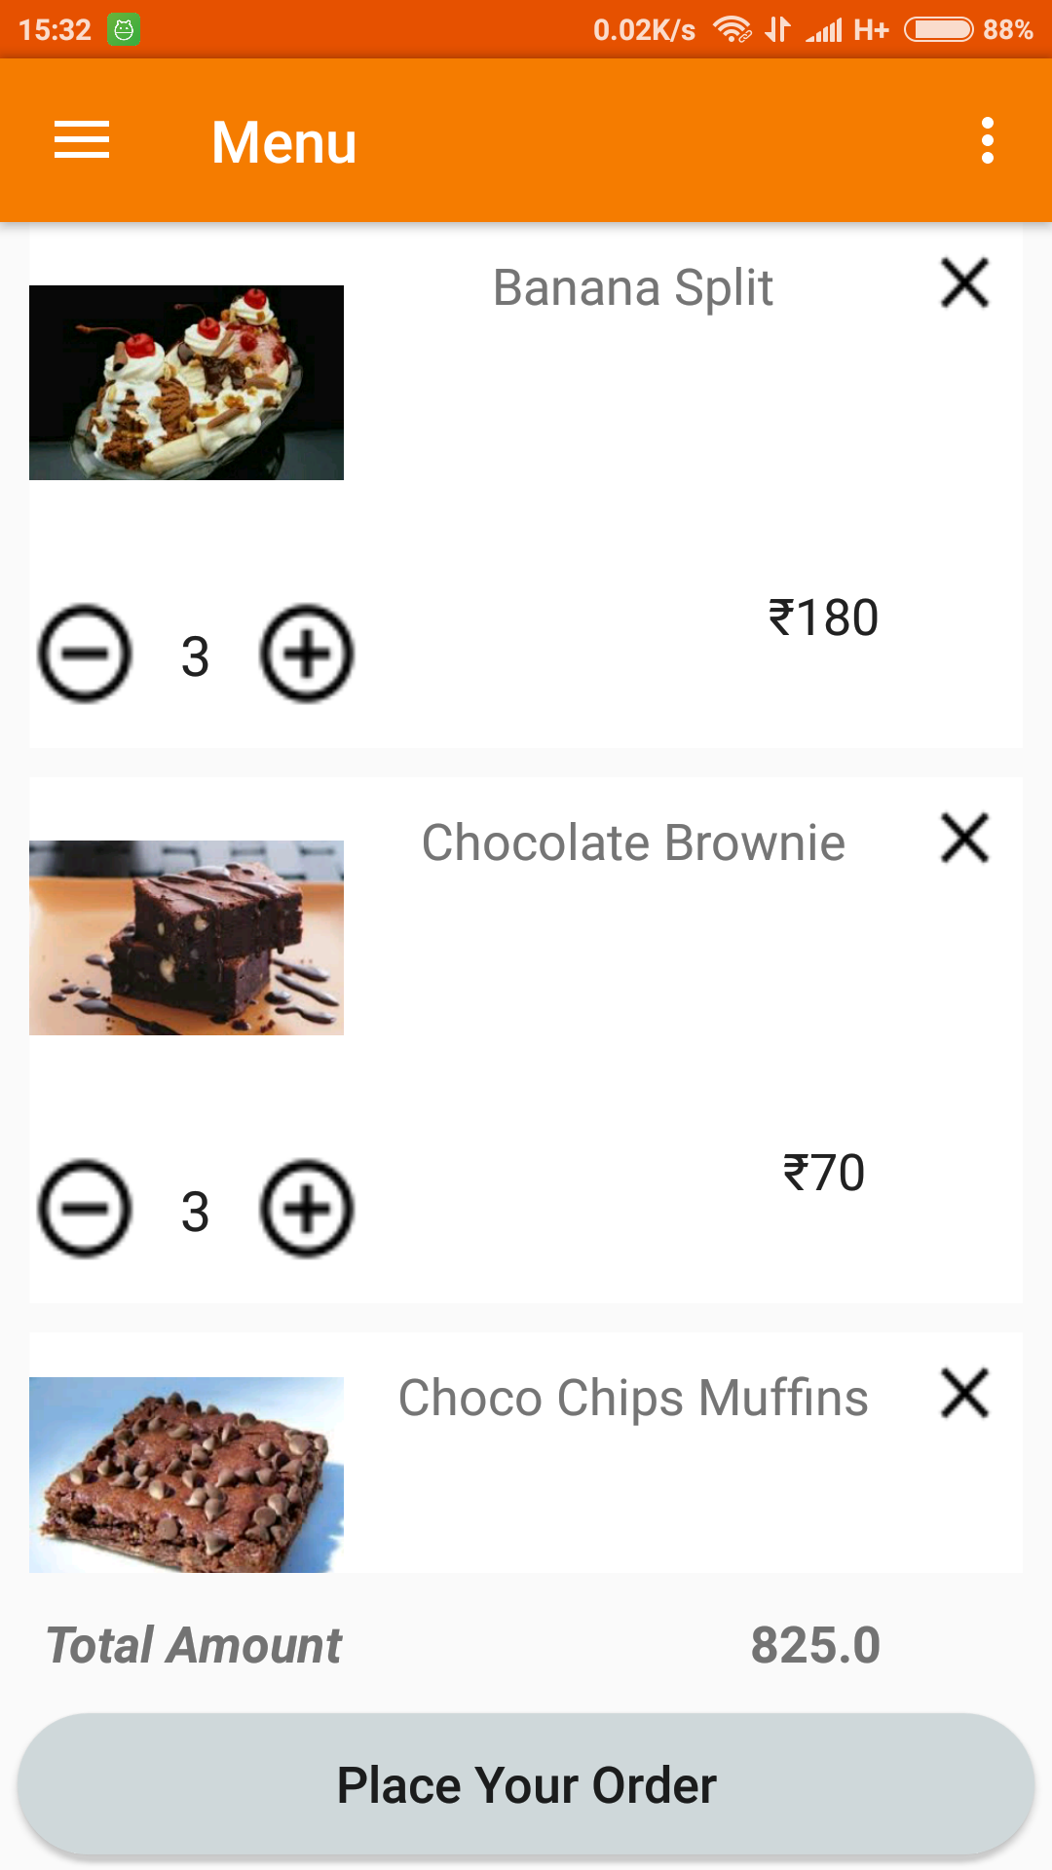

**Fig. 3.2.7 Snapshot of Cart Screen**

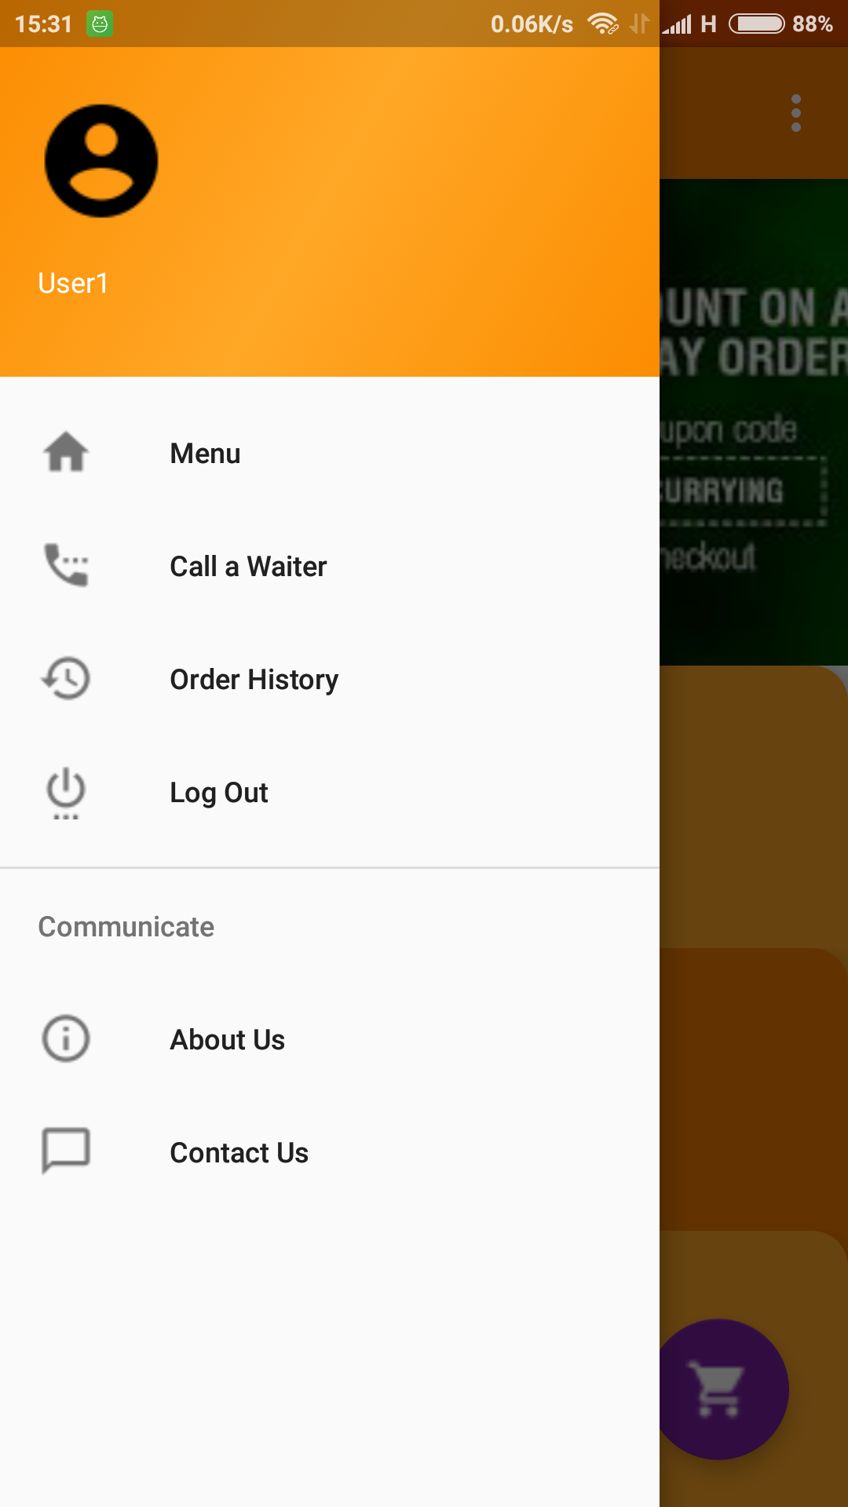

**Fig. 3.2.8 Snapshot of Navigation Drawer Screen**

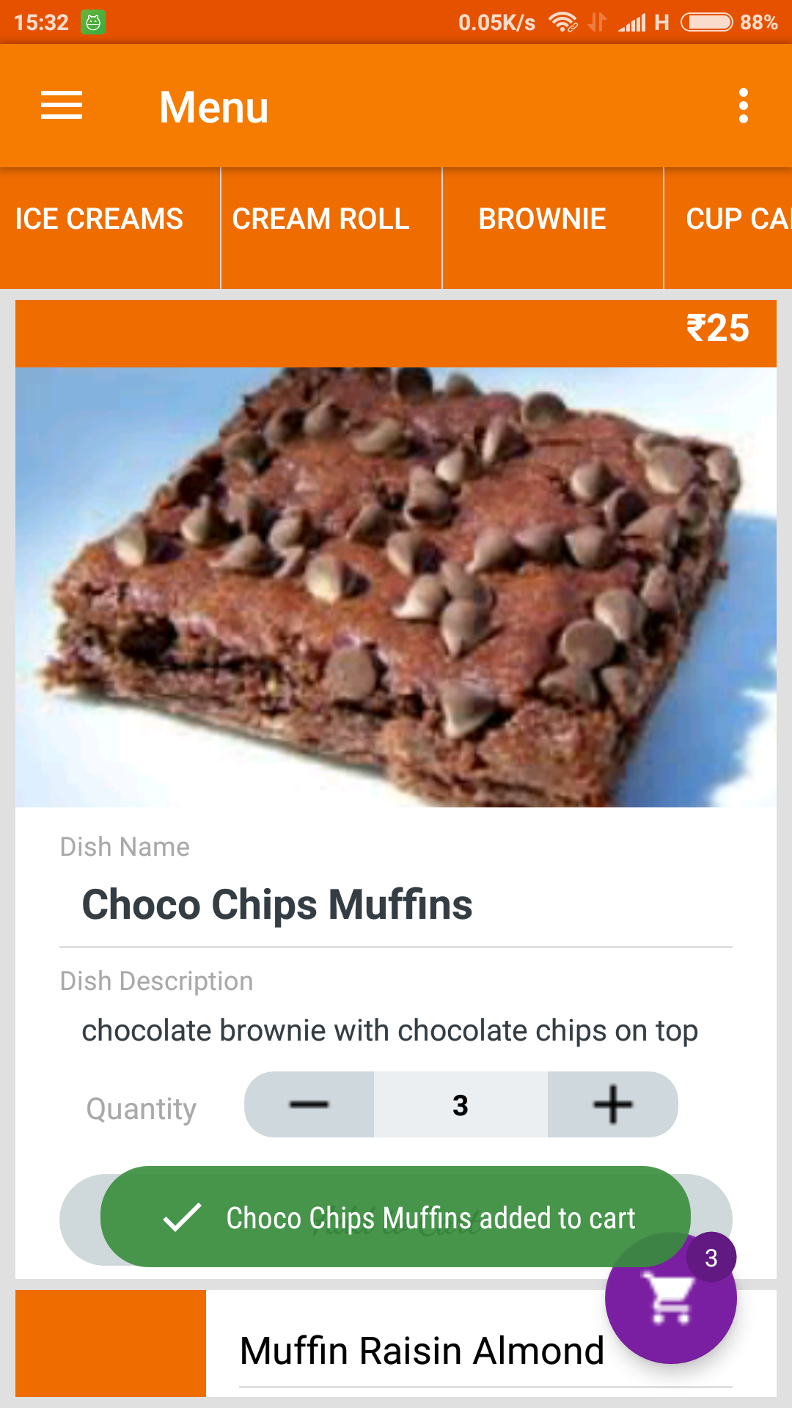

**Fig. 3.2.9 Snapshot of Order placing**

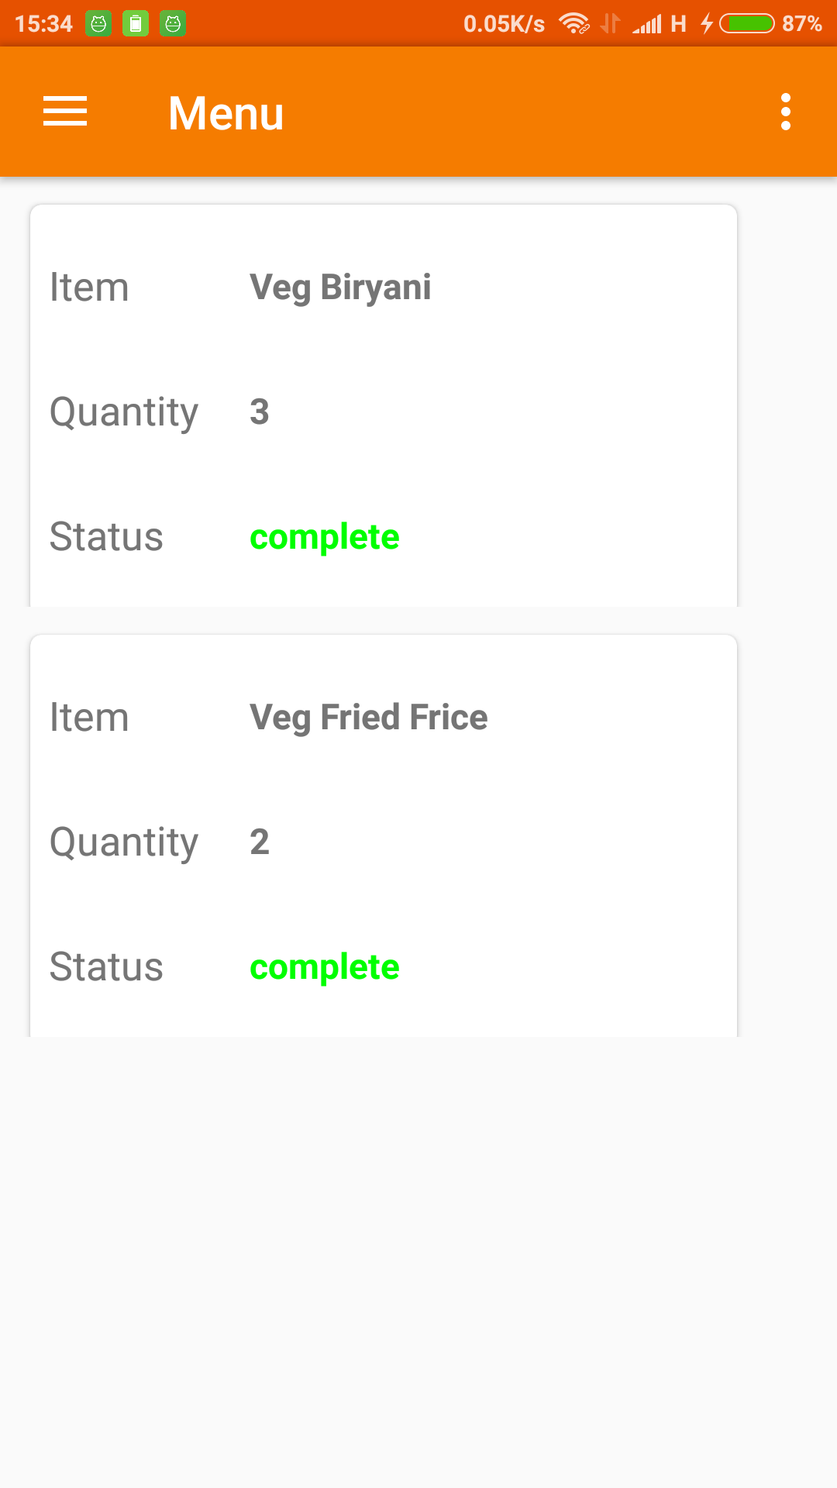

**Fig. 3.2.10 Snapshot of Order Status Screen**

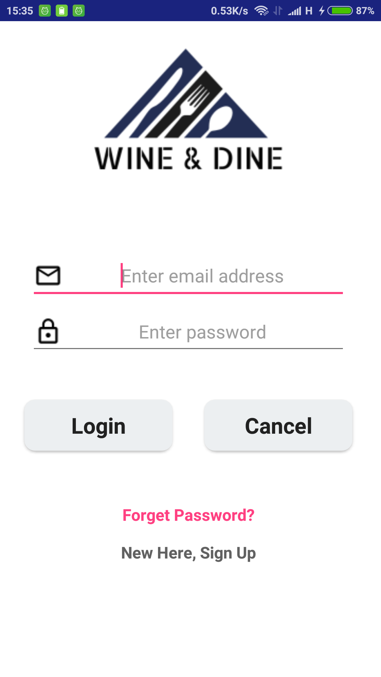

**Fig. 3.2.11 Snapshot of Admin Login Screen**

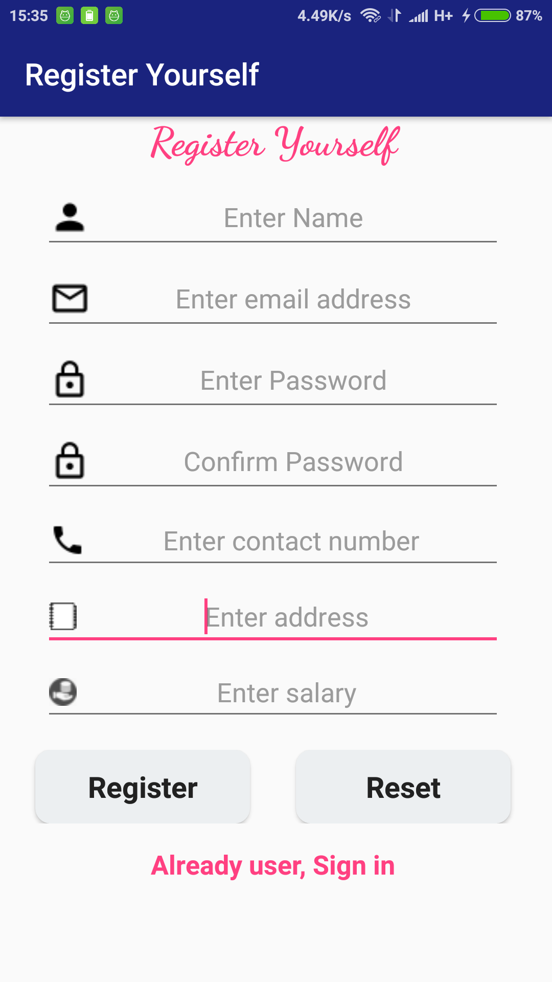

**Fig. 3.2.12 Snapshot of Admin Register Screen**

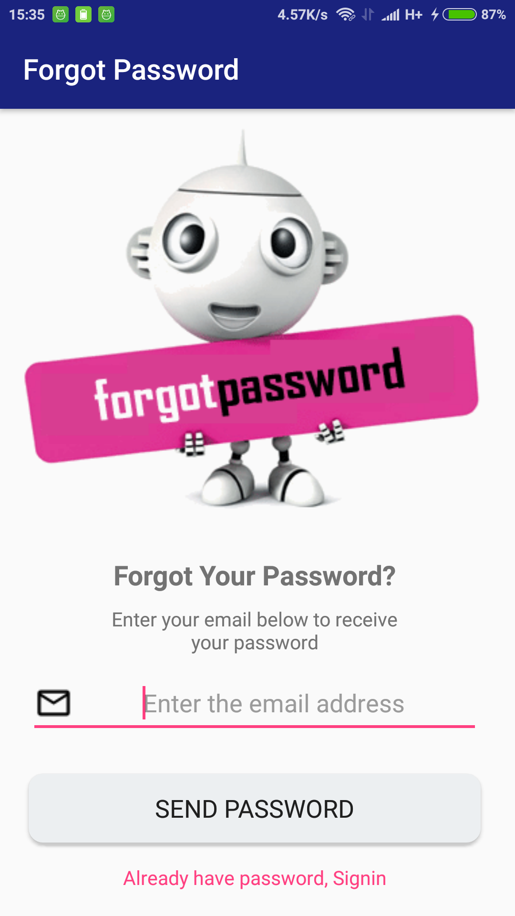

**Fig. 3.2.13 Snapshot of Forgot Password Screen**

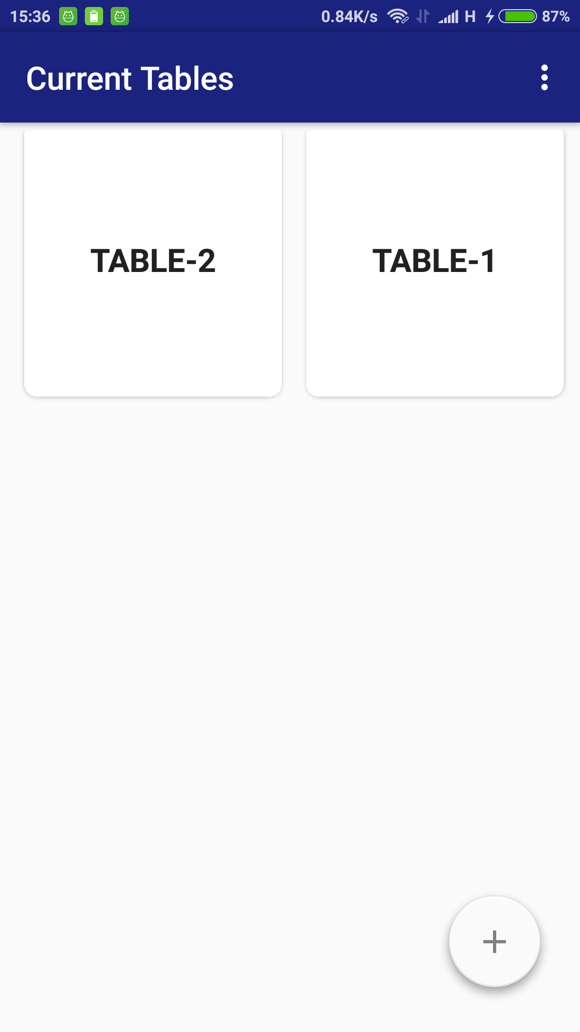

**Fig. 3.2.14 Snapshot of Admin Home Screen**

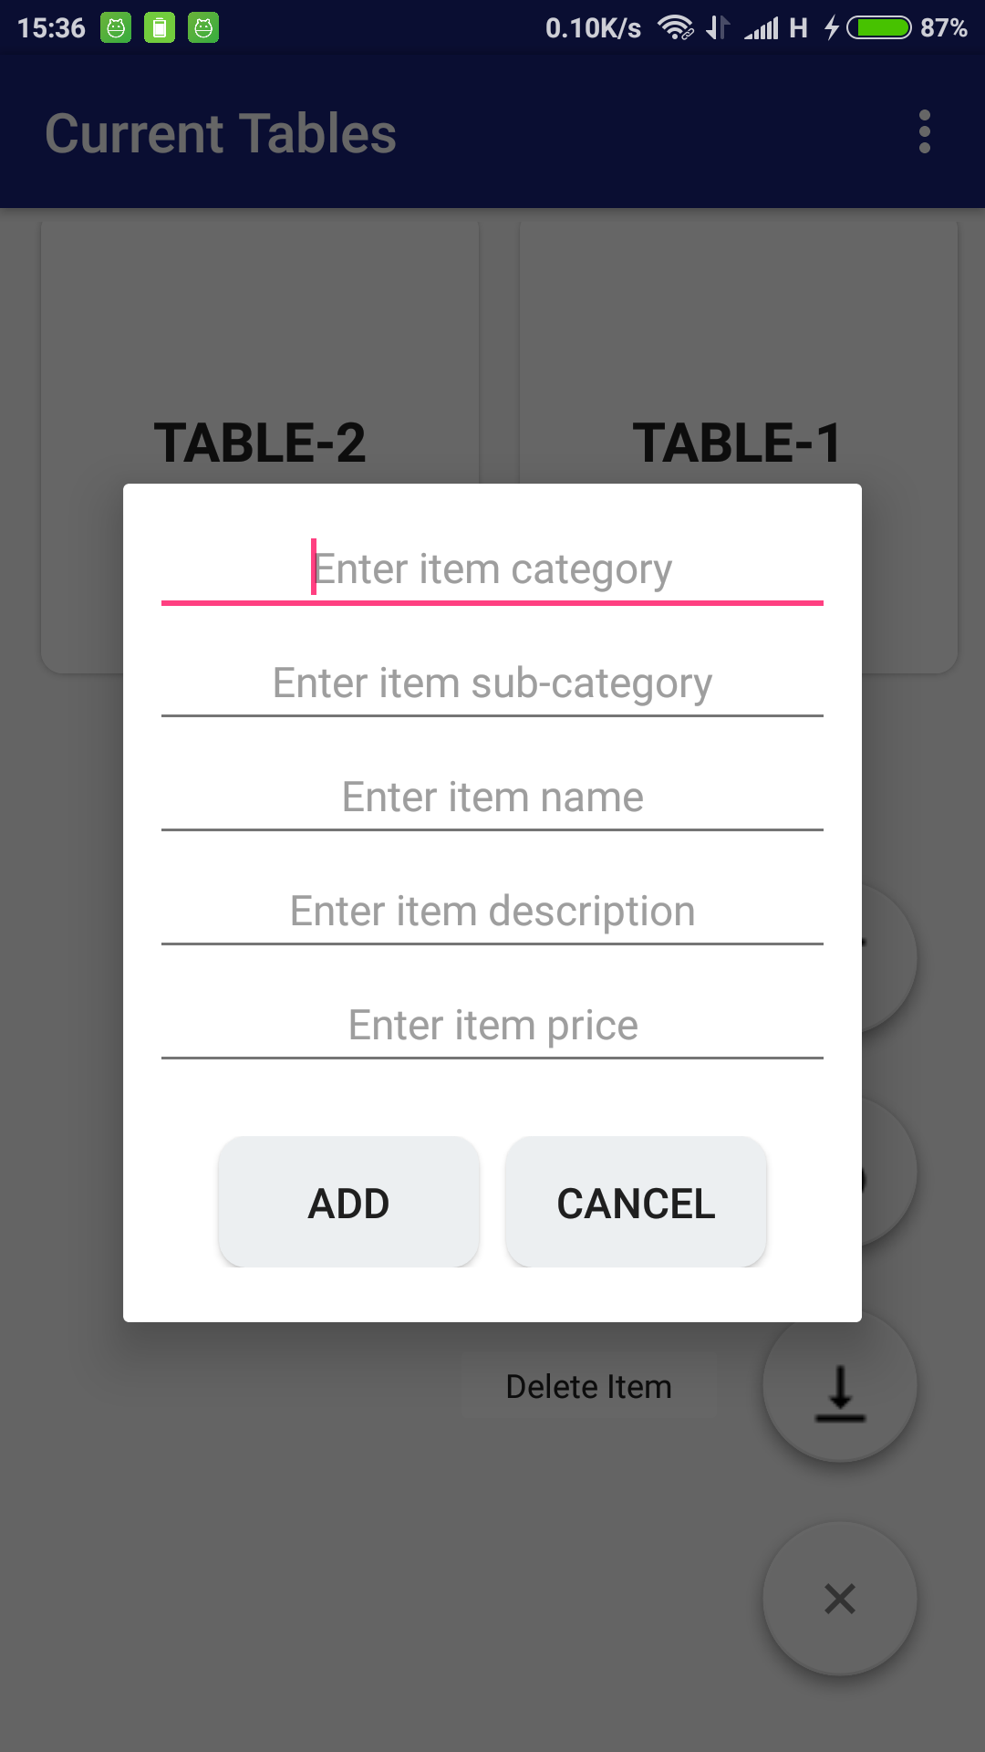

**Fig. 3.2.15 Snapshot of Add Menu Screen**

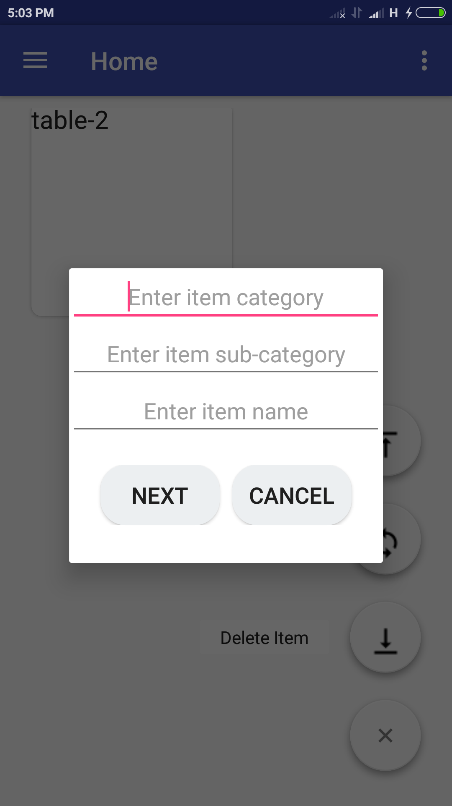

**Fig. 3.2.16 Snapshot of Update menu Screen(1)**

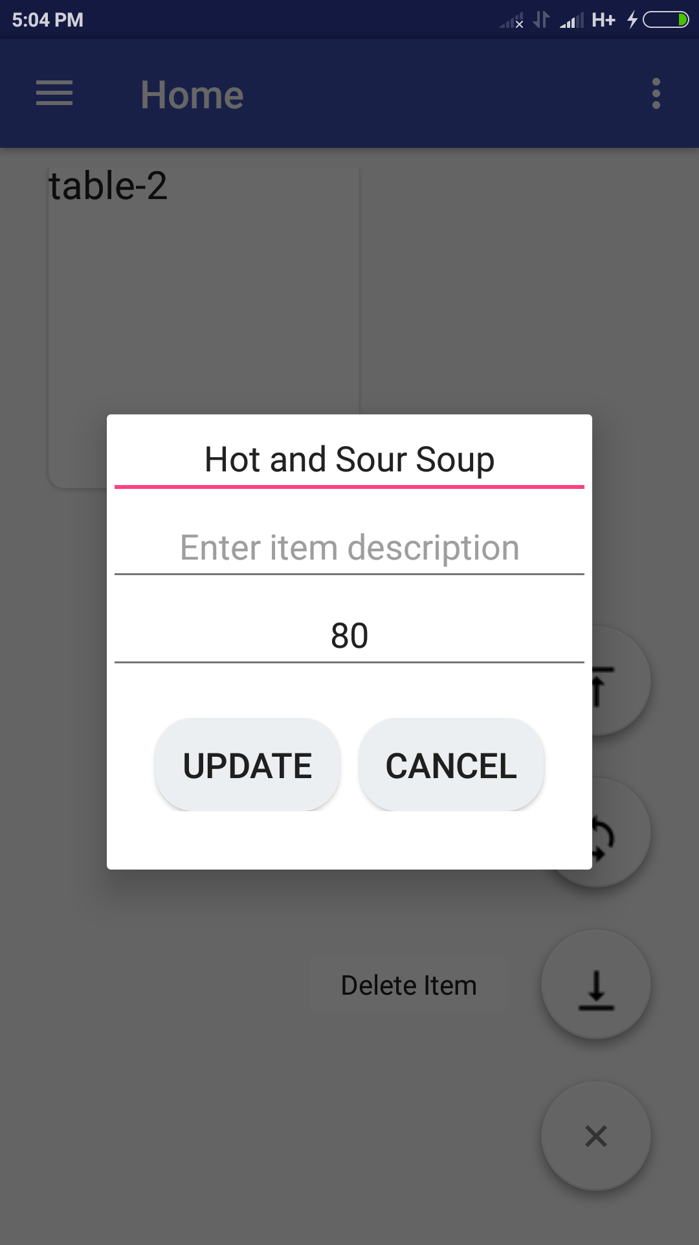

**Fig. 3.2.17 Snapshot of Update menu Screen(2)**

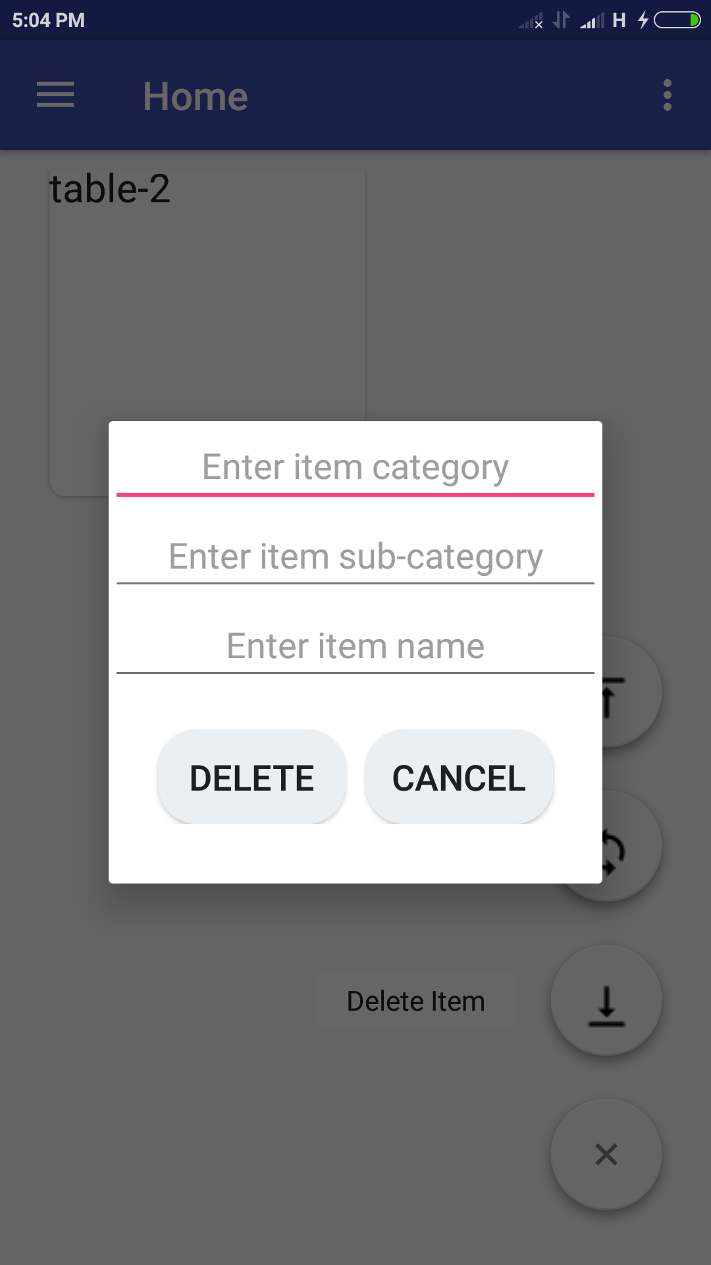

**Fig. 3.2.18 Snapshot of Delete menu Screen**

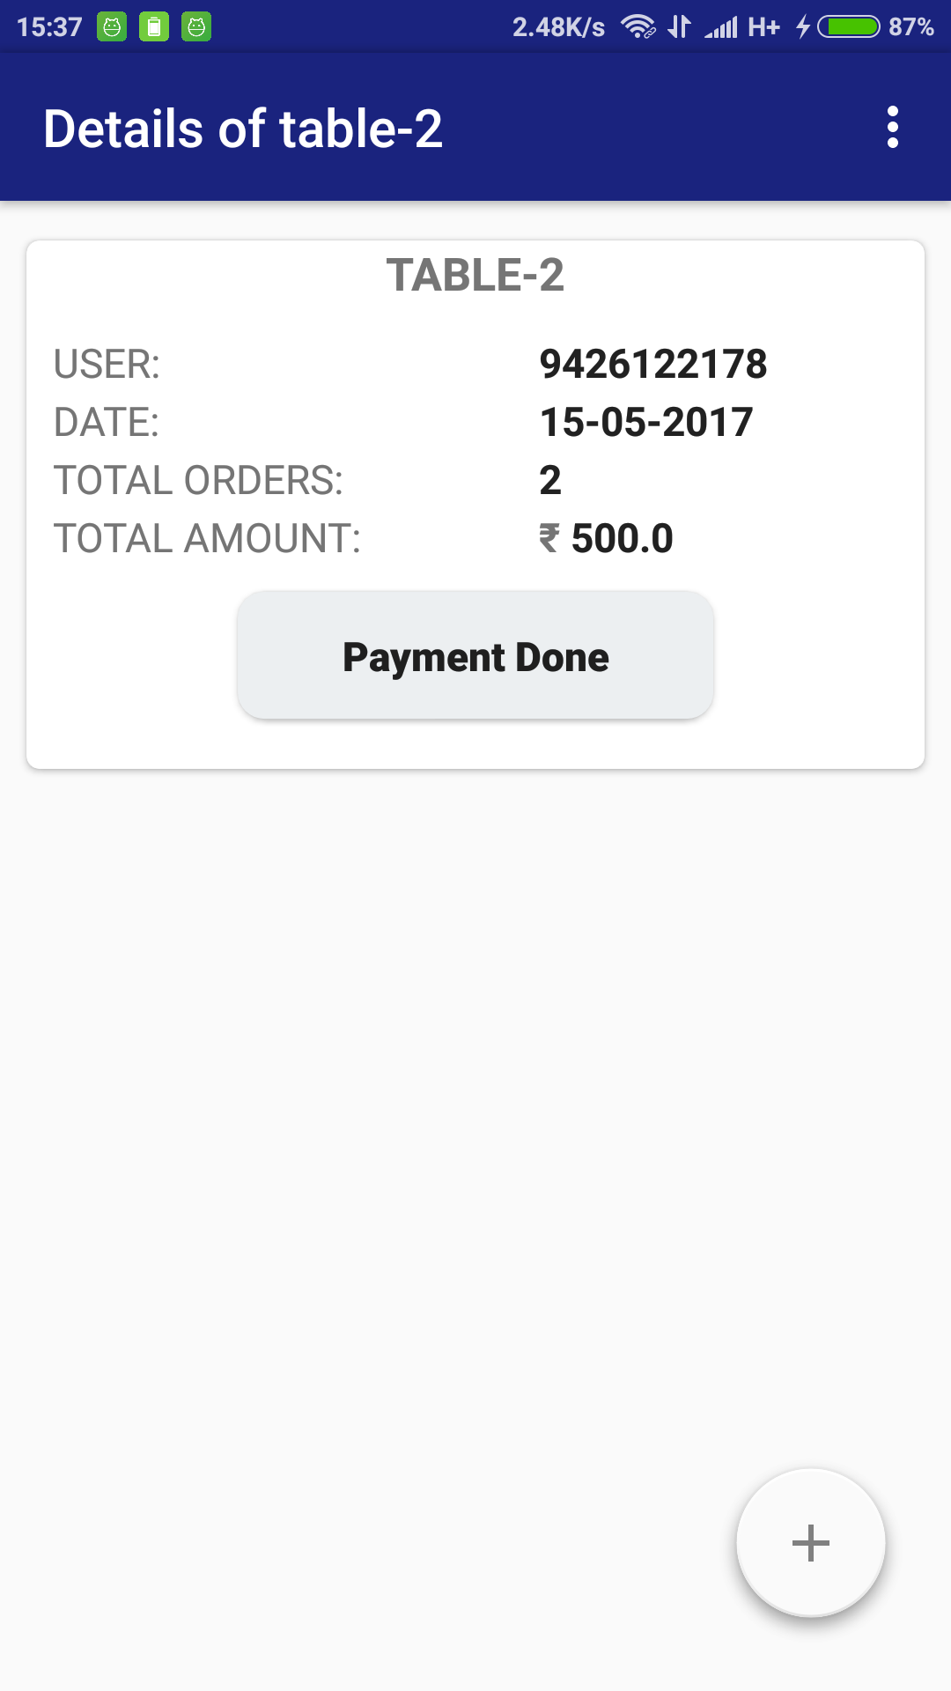

**Fig. 3.2.19 Snapshot of Individual Table Screen**

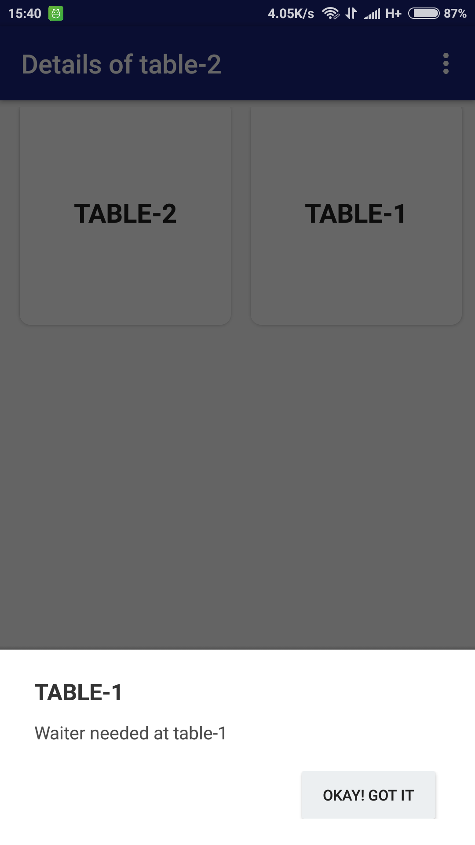

**Fig. 3.2.20 Snapshot of Waiter’s call Screen**

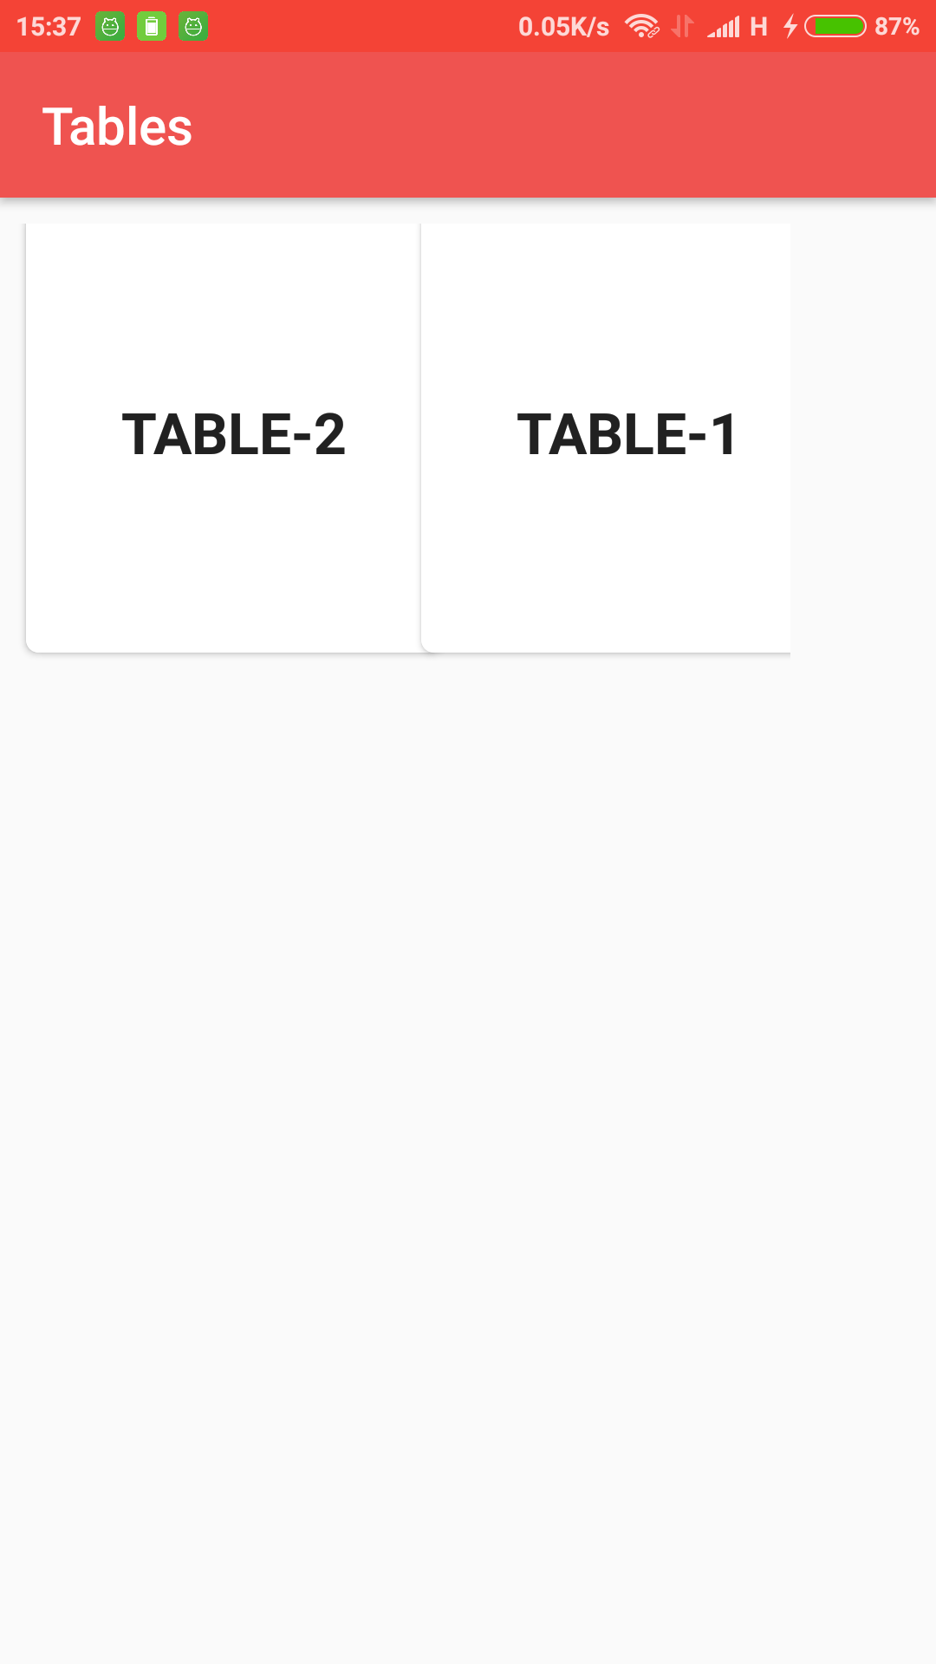

**Fig. 3.2.21 Snapshot of Kitchen Home Screen**

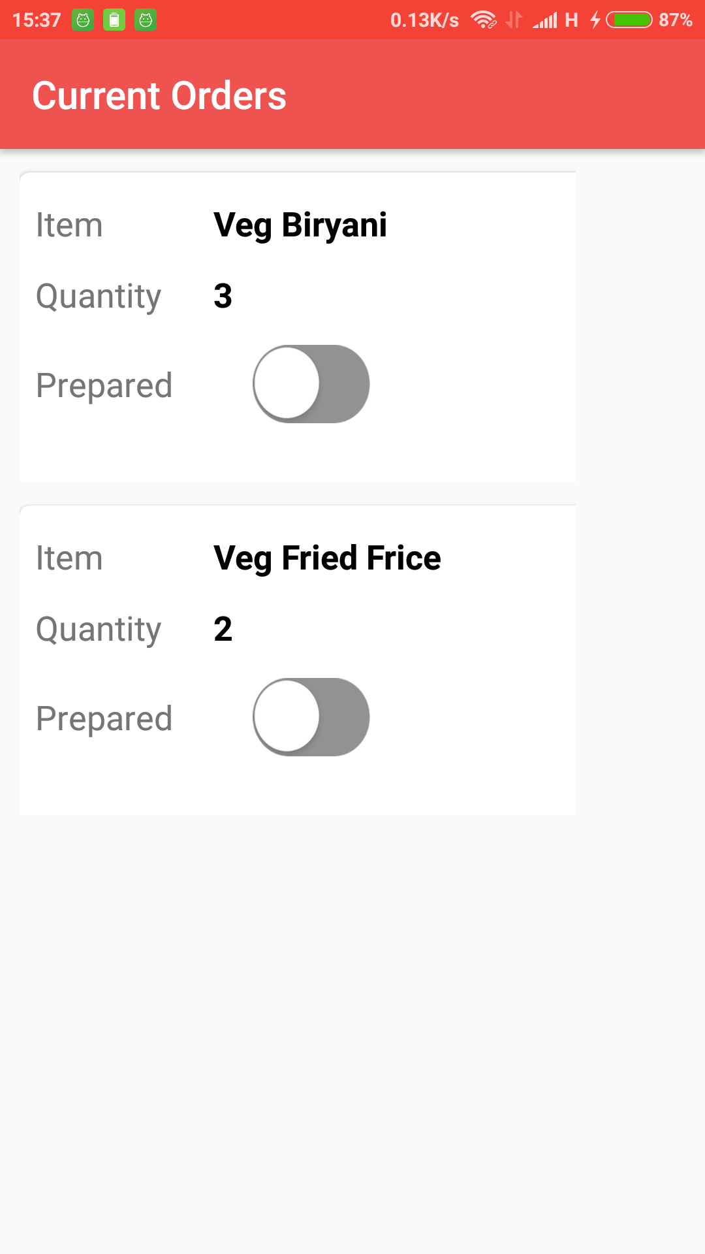

**Fig. 3.2.22 Snapshot of Individual table order Screen**

**Chapter-3: RESULT SUMMARY**

After completing the entire project, we successfully conclude that the above project will provide a complete and best solution for Restaurant Management system. We have done the work according to the pre-planned schedule given with the time constrains and result oriented progress in the project development.

Our project started in First week of July and we are able complete this project by the ending of April. Initially, there were some constraints regarding some phases but we planned it out and reconciled those problems. We had divided our work in different phases and solved the arising problems and difficulties in during this period of time.

**Advantages of methodologies:**

* The Prototype model helped us in coping with constant modifications in the software without losing track of core functionality.
* Regular testing with maximum possible test cases has helped to make it a truly robust system.

**Future Enhancements:**

* Customer can reserve the table and get remainder and notification regarding the location of the customer.
* Can pay through debit card or credit card or net banking

**References**

1. <http://istqbexamcertification.com/what-is-prototype-model-advantages-disadvantages-and-when-to-use-it>
2. <https://www.tutorialspoint.com/sdlc/sdlc_software_prototyping.htm>
3. Michael Blaha and James Rambaugh, "Oriented Modeling and Design with UML", Second Edition, Publisher: Prentice Hall , 1991.
4. Roger S Pressman ,"Software Engineering-A Practitioner’s Approach”, Seventh Edition , Publisher : McGraw-Hill ,2009.
5. <http://www.alexandercowan.com/business-model-canvas-templates/>
6. <https://en.wikipedia.org/wiki/Android_Studio>
7. <https://en.wikipedia.org/wiki/Firebase>
8. <http://stackoverflow.com/questions/12912181/simplest-yes-no-dialog-fragment>
9. <https://android-arsenal.com/details/1/5168>
10. <http://stackoverflow.com/questions/28601663/how-to-retrieve-specific-node-from-firebase-database-in-android>
11. <https://androidician.wordpress.com/2014/09/24/android-custom-toggle-button-example-ios-like-toggle-buttons/>
12. <http://stackoverflow.com/questions/13487708/how-to-make-a-view-invisible-gone-onbackpressed-method-in-android>
13. <http://stackoverflow.com/questions/2271131/display-the-current-time-and-date-in-an-android-application>
14. <http://www.vogella.com/tutorials/AndroidDialogs/article.html>
15. <https://android--code.blogspot.in/2015/12/android-recyclerview-grid-layout-example.html>
16. <https://android-arsenal.com/details/1/965>
17. <http://www.truiton.com/2016/09/android-example-programmatically-scan-qr-code-and-bar-code/>
18. <https://android-arsenal.com/details/1/5052>
19. <https://inducesmile.com/android/android-mapview-example-tutorial/>
20. <https://android-arsenal.com/details/1/3600>
21. <https://android-arsenal.com/details/1/4701>
22. <http://sampleprogramz.com/android/gmap.php>
23. <https://material.io/guidelines/style/color.html#color-color-palette>
24. <https://android-arsenal.com/details/1/5102>
25. <http://www.mysamplecode.com/2011/10/android-programmatically-generate.html>
26. <http://subinsb.com/send-mails-via-smtp-server-gmail-outlook-php>
27. <http://stackoverflow.com/questions/15809399/android-notification-sound>
28. <https://www.tutorialspoint.com/android/android_notifications.htm>
29. <http://www.vogella.com/tutorials/AndroidNotifications/article.html>
30. <https://inducesmile.com/android/using-braintree-payment-in-android-to-accept-payment/?cid=1582>
31. <https://github.com/braintree/braintree_android>
32. <https://inducesmile.com/android/android-mapview-example-tutorial/#comment-1491>
33. <http://stackoverflow.com/questions/30991087/mapfragment-getmapasyncthis-nullpointerexception/33644654>
34. <https://gist.github.com/joshdholtz/4522551>
35. <http://stackoverflow.com/questions/16666248/create-feedback-form-in-android>
36. <https://www.mkyong.com/android/android-rating-bar-example/>
37. <http://www.viralandroid.com/2016/01/simple-android-user-contact-form-xml-ui-design.html>
38. <http://stackoverflow.com/questions/21131110/add-dynamically-edittext-in-dialogue>
39. <http://stackoverflow.com/questions/36225338/dynamically-update-text-within-custom-layout-dialog-npe-android>

**Appendix**